Lesson Map with Pictures for the Thermochemistry Lesson: How do hand warmers work?
This unit addresses Physical Science PE HS-PS1-4 and Engineering Design PE of HS-WTS1-3 by engaging students in developing models around energy transfer and thermochemistry. Students will connect the energy changes at the particulate level through simulations to the macro level in terms of system and surrounds. Students plan and carry out investigations as performance tasks, analyze the data through collaborative group work and engage in research to find the best material for the hand warmers. Students then design the hand warmer through iterative design thinking process.

Performance Expectation
HS-PS1-4. Develop a model to illustrate that the release or absorption of energy from a chemical reaction system depends upon the changes in the total bond energy.

Performance Expectation
HS-ETS1-3. Evaluate a solution to a complex real-world problem based on prioritized criteria and trade-offs that account for a range of constraints, including cost, safety, reliability and aesthetics as well as possible social, cultural and environmental impacts.

This unit has three lessons:

Lesson # | Type of Activity | Time | Target Concept |  | Materials | Corresponding picture #
Lesson 1 (day 1) | Small group and whole class discussion, pHET simulation, group performance task | 1 period of 45 minutes | Gauging students’ prior knowledge of ice and hot packs, developing models around energy transfer at particulate and macro level, understanding exo and endothermic reactions in terms of heat transfer |  | Handouts, computers or at least one computer to project the simulation, performance task equipment- goggles, beakers, thermometer, water, salts- sodium acetate and ammonium nitrate, waste containers |  | #1
Formative Assessment 1 | Exit Slip
Lesson 2 (day 2) | Individual work, small group work, individual work around watching youtube video | 1 period of 45 minutes |  | System and surroundings, energy transfer in exo and endothermic reactions, using mathematical computation and thinking to further understand energy transfer during exo and endothermic reactions, using youtube video to gain further understanding of the energy diagrams in exo and endothermic reactions | Materials: Handouts, computers or one class computer |  | #2
Formative Assessment (day 3) | Individual and small group work, whole class discussion | 1 period of 45 minutes |  | All concepts so far | Individual handouts (one per group member) and group report (only one handout per group) |  | #3-7
Lesson 3 (day 4-8)
Day 4 | Designing and constructing an experiment for performance task 2 | 1 period of 45 minutes |  | Evaluating the best salt for hand warmer based upon increase in temperature and time, aligned with the first criterion for a good hand warmer | Handout, For each group of 4 students: goggles, 2-500 mL beakers, two thermometers, 1-50 mL graduated cylinder, watch and a waste beaker |  | #8
Day 5 | Individual Online Research | 1 period of 45 minutes |  | Students do online research for the cost and environmental friendliness of each of the three salts and record their findings. | Handout, one computer per student |  | #9, 10
Day 6 | Claim, Evidence and Reasoning for the best salt for the hand warmer based upon class data | 1 period 45 minutes |  | Students fill in class data and record the averages in their handout. Then, they write the claim, evidence and reasoning for the best salt for hand warmer based on this data. | Handout |  | #11, 12,  13
Day 7 | Peer editing of Claim, Evidence and Reasoning | 1 period 45 minutes |  | Engaging in peer editing of Claim, Evidence and Reasoning and writing the second draft after self assessing against the rubric after peer editing | Handout and rubric for self -assessment |  | #14,15
Day 8 | Designing the hand warmer,  Class Debate | 1 period 45 minutes |  | Designing the actual hand warmer either individually or in group after watching the video, then engaging in a debate for the best material for hand warmer from a different perspective of a manufacturer, a consumer or an environmentalist | Computer, For each group of 4 students: Goggles, two Ziploc bags- one snack and one sandwich, desired salt, water and waste container |  | #16
Note: I used the claim, evidence and reasoning as the summative for this lesson.

Pictures: #1, 2: Performance task #1, Day 1 Picture #2, Day 2

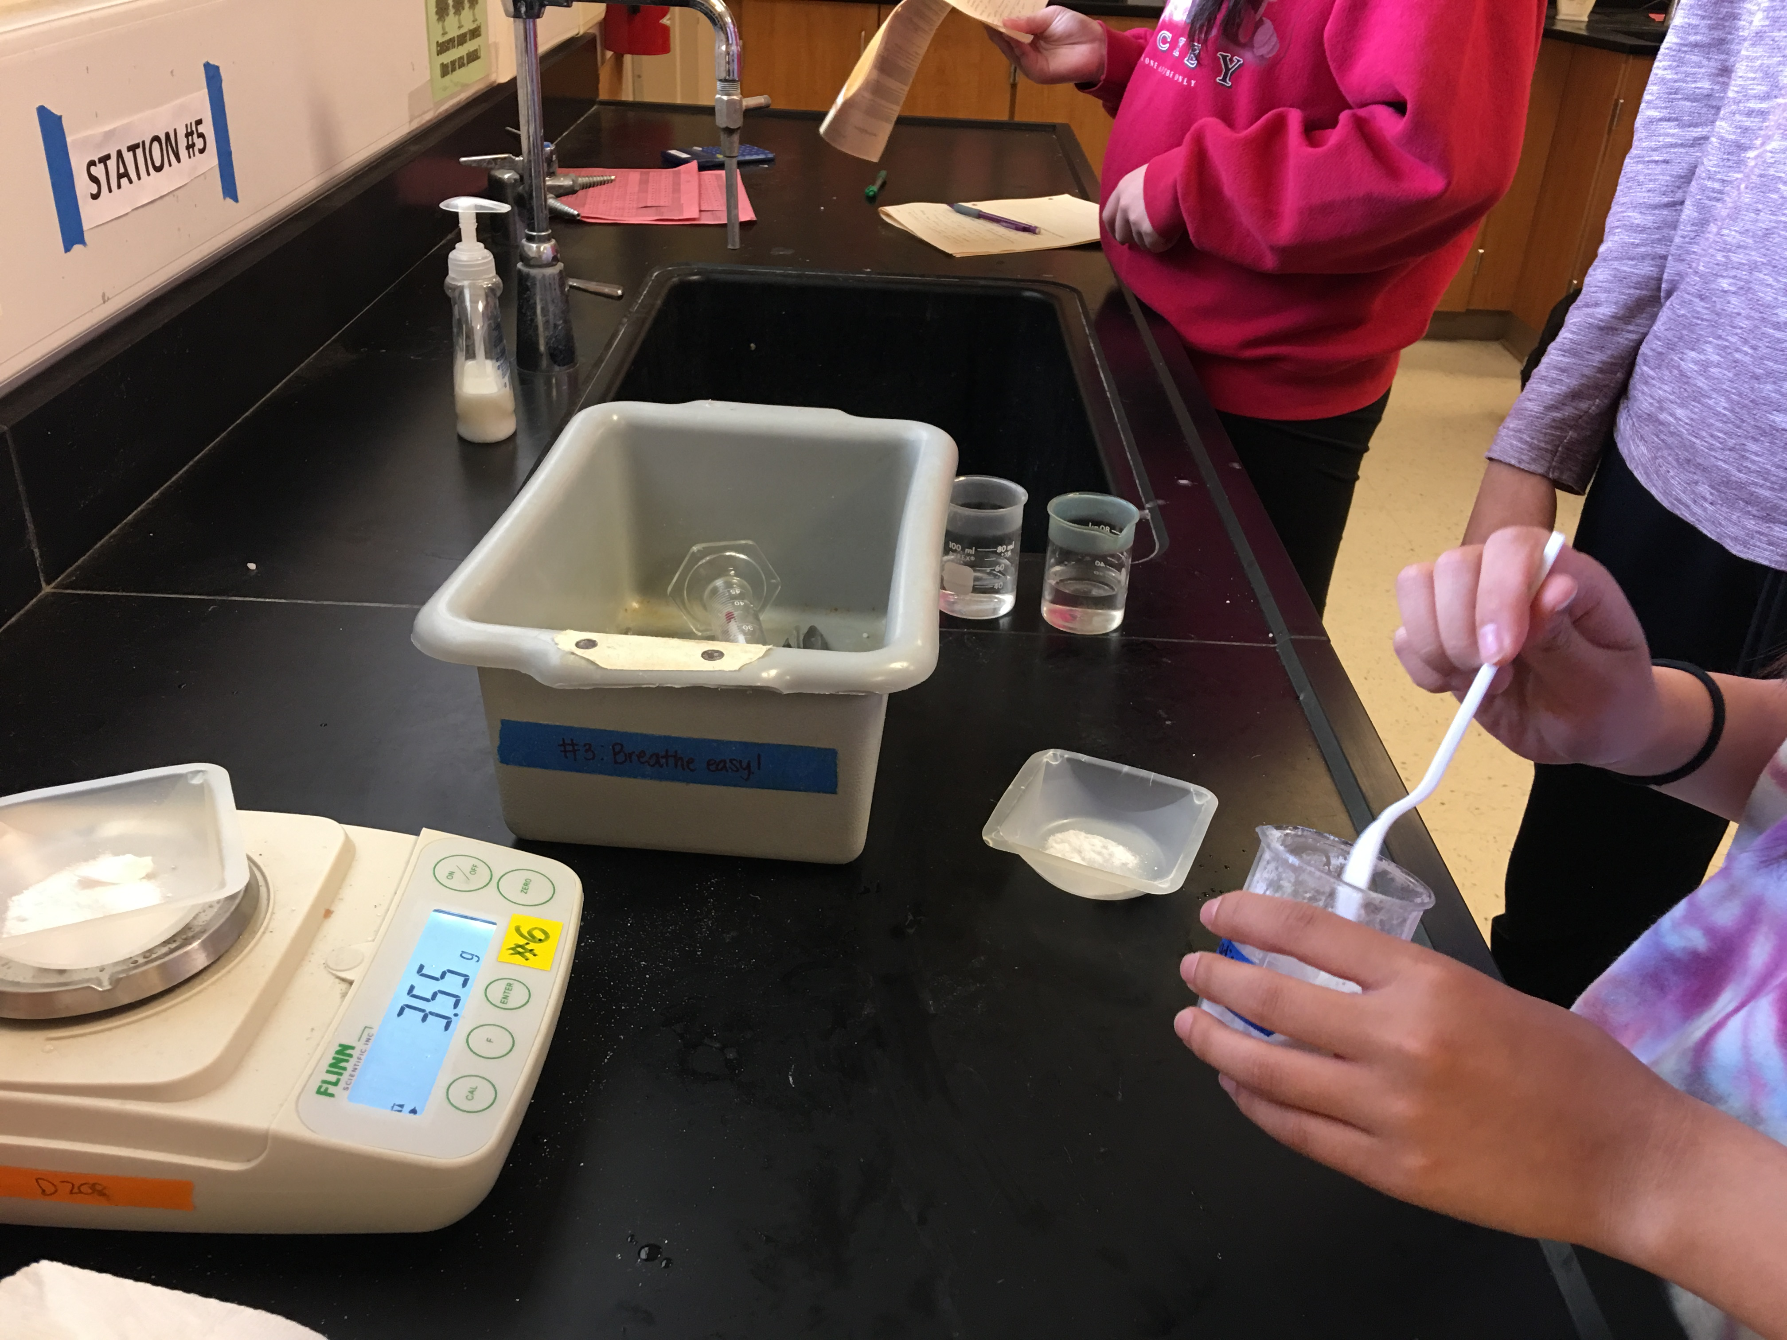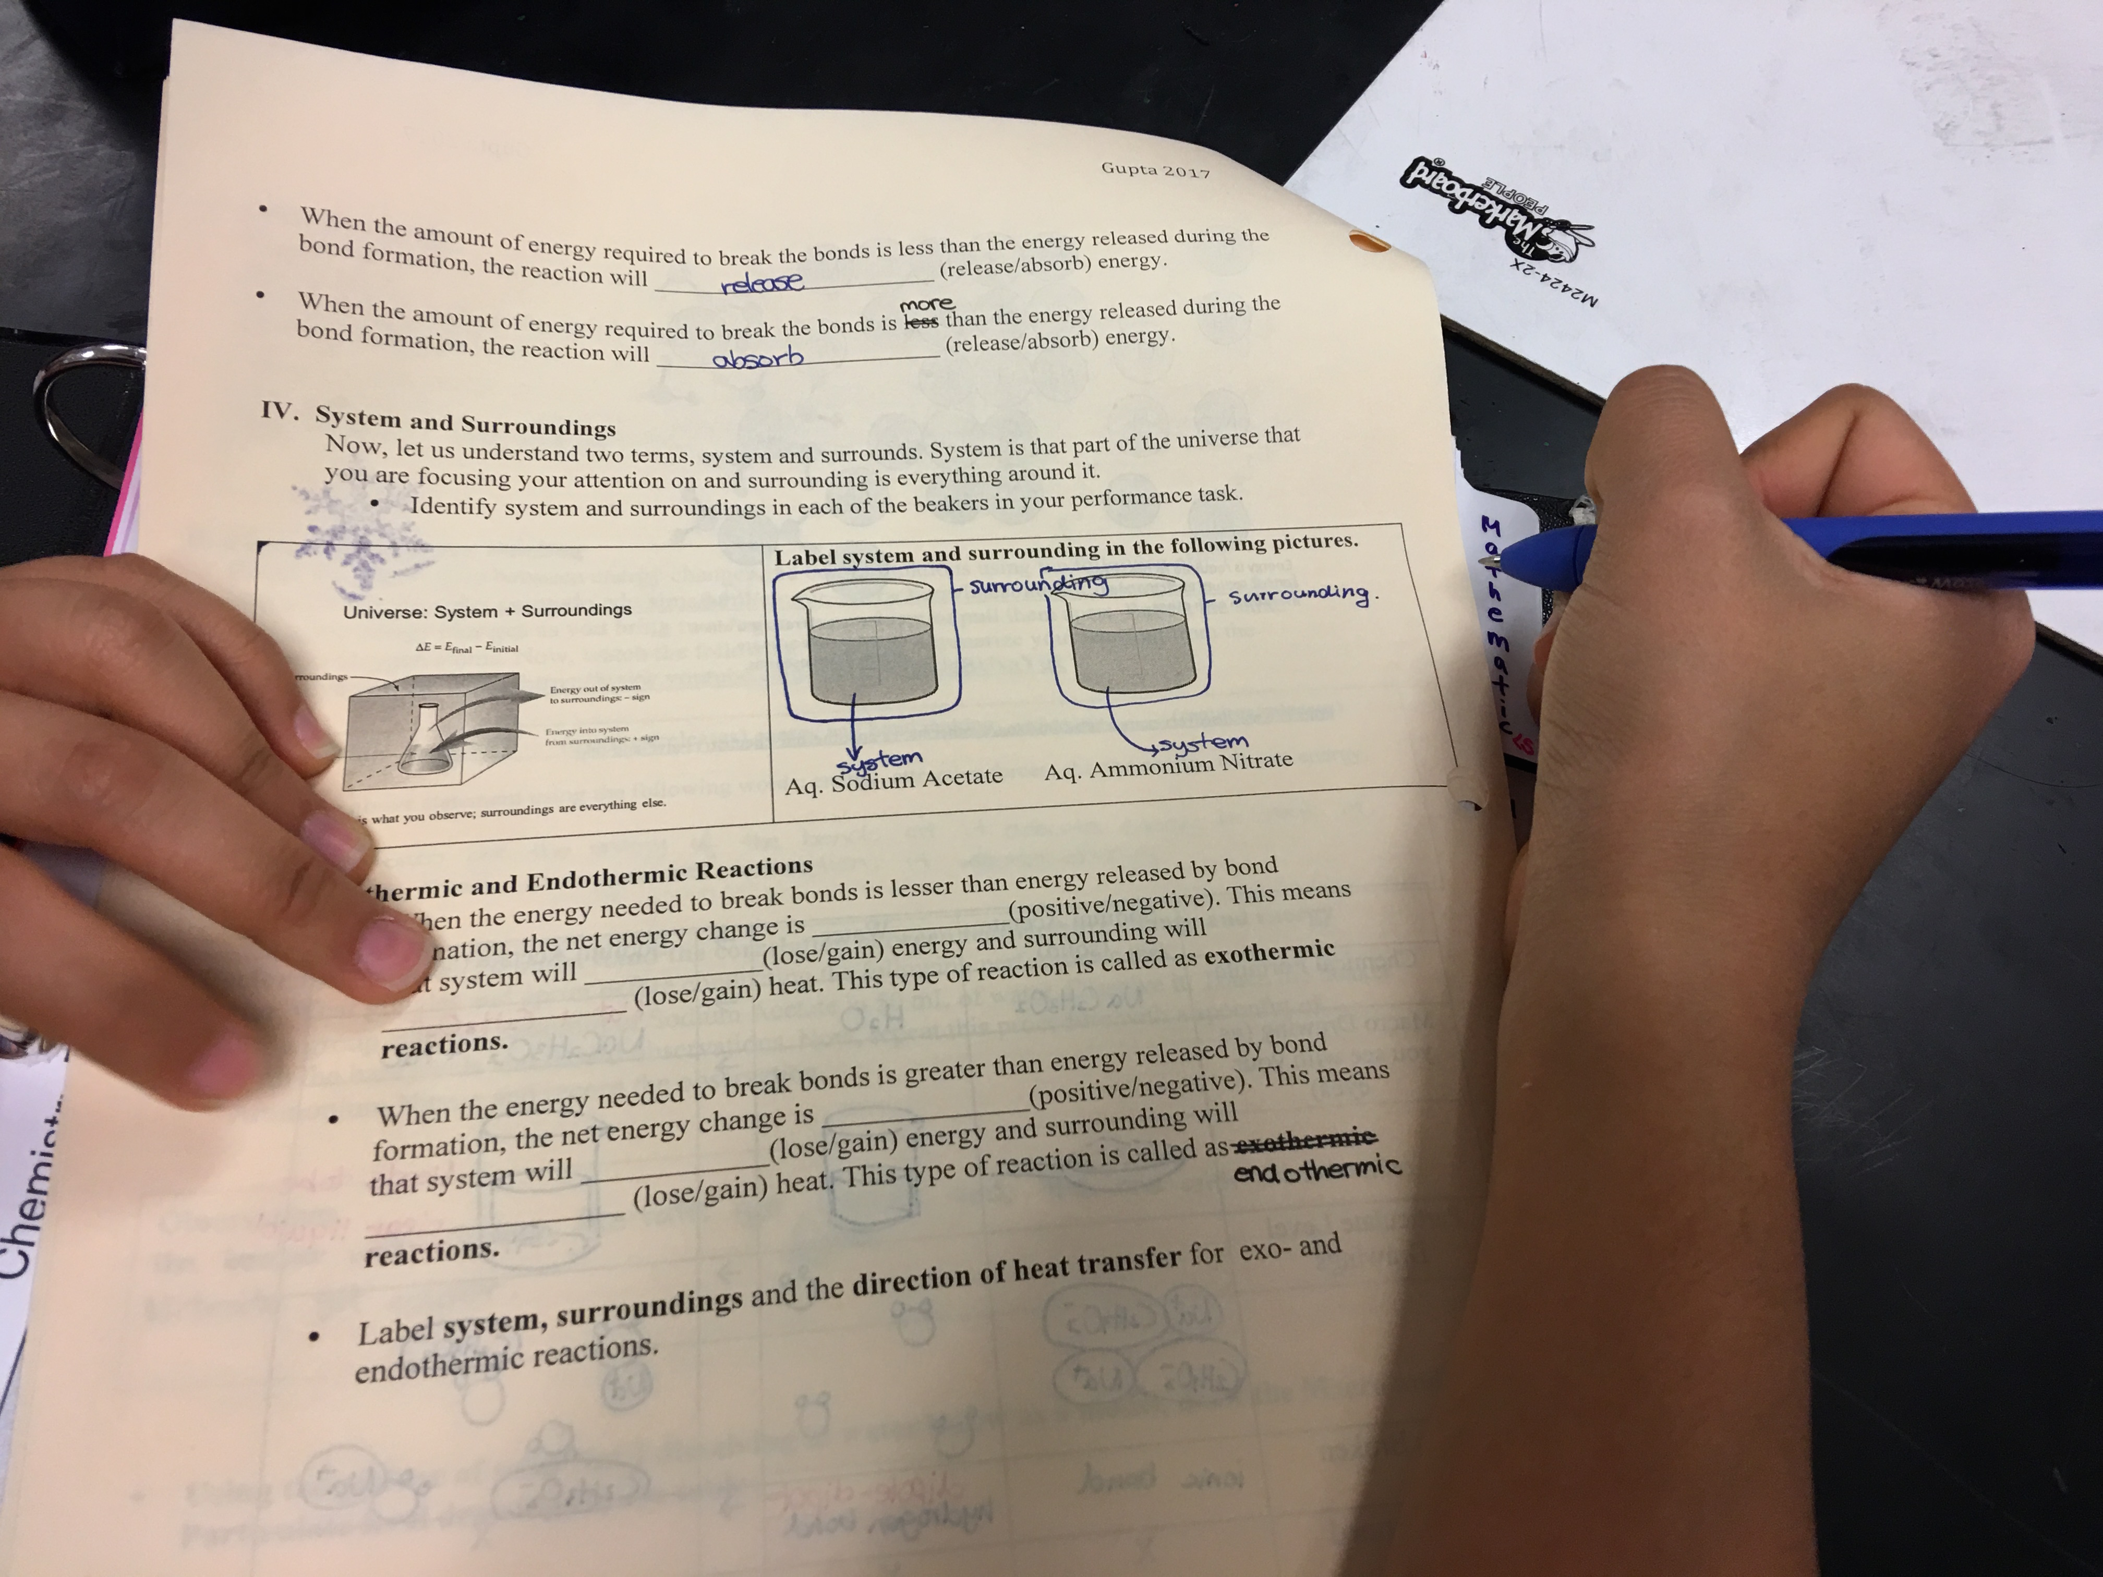

Picture # 3, 4, 5 Day 3 Individual Report

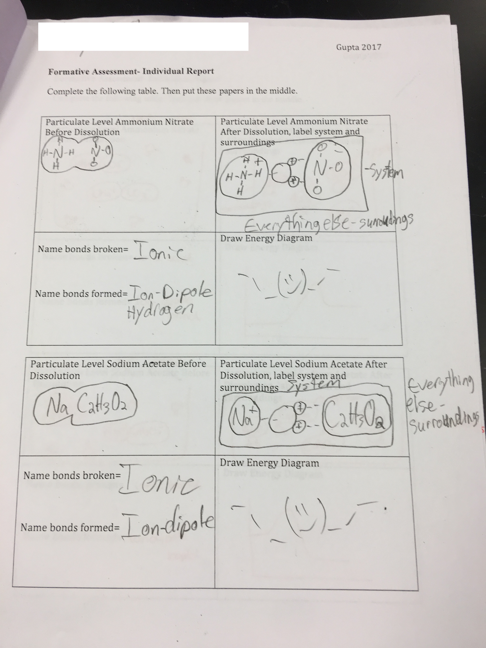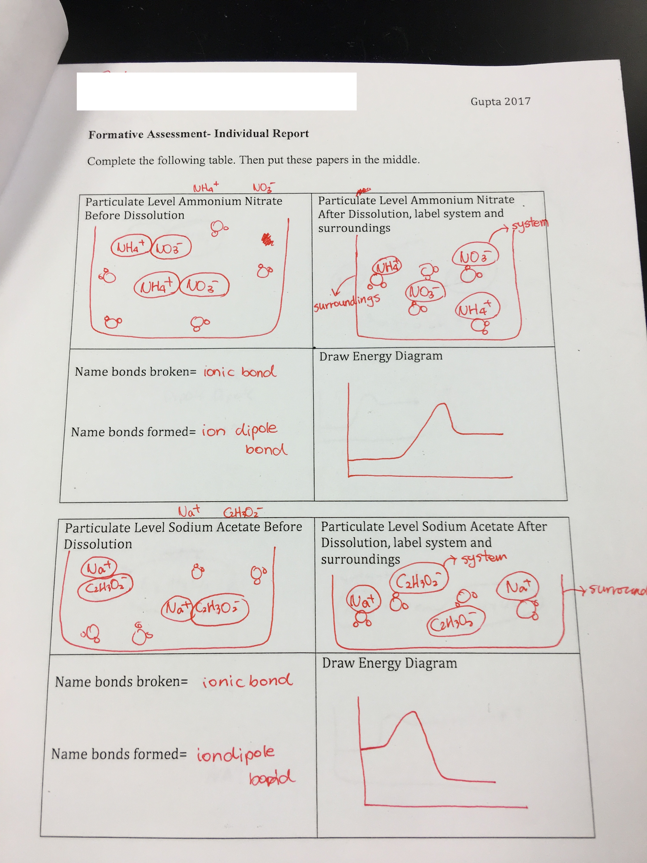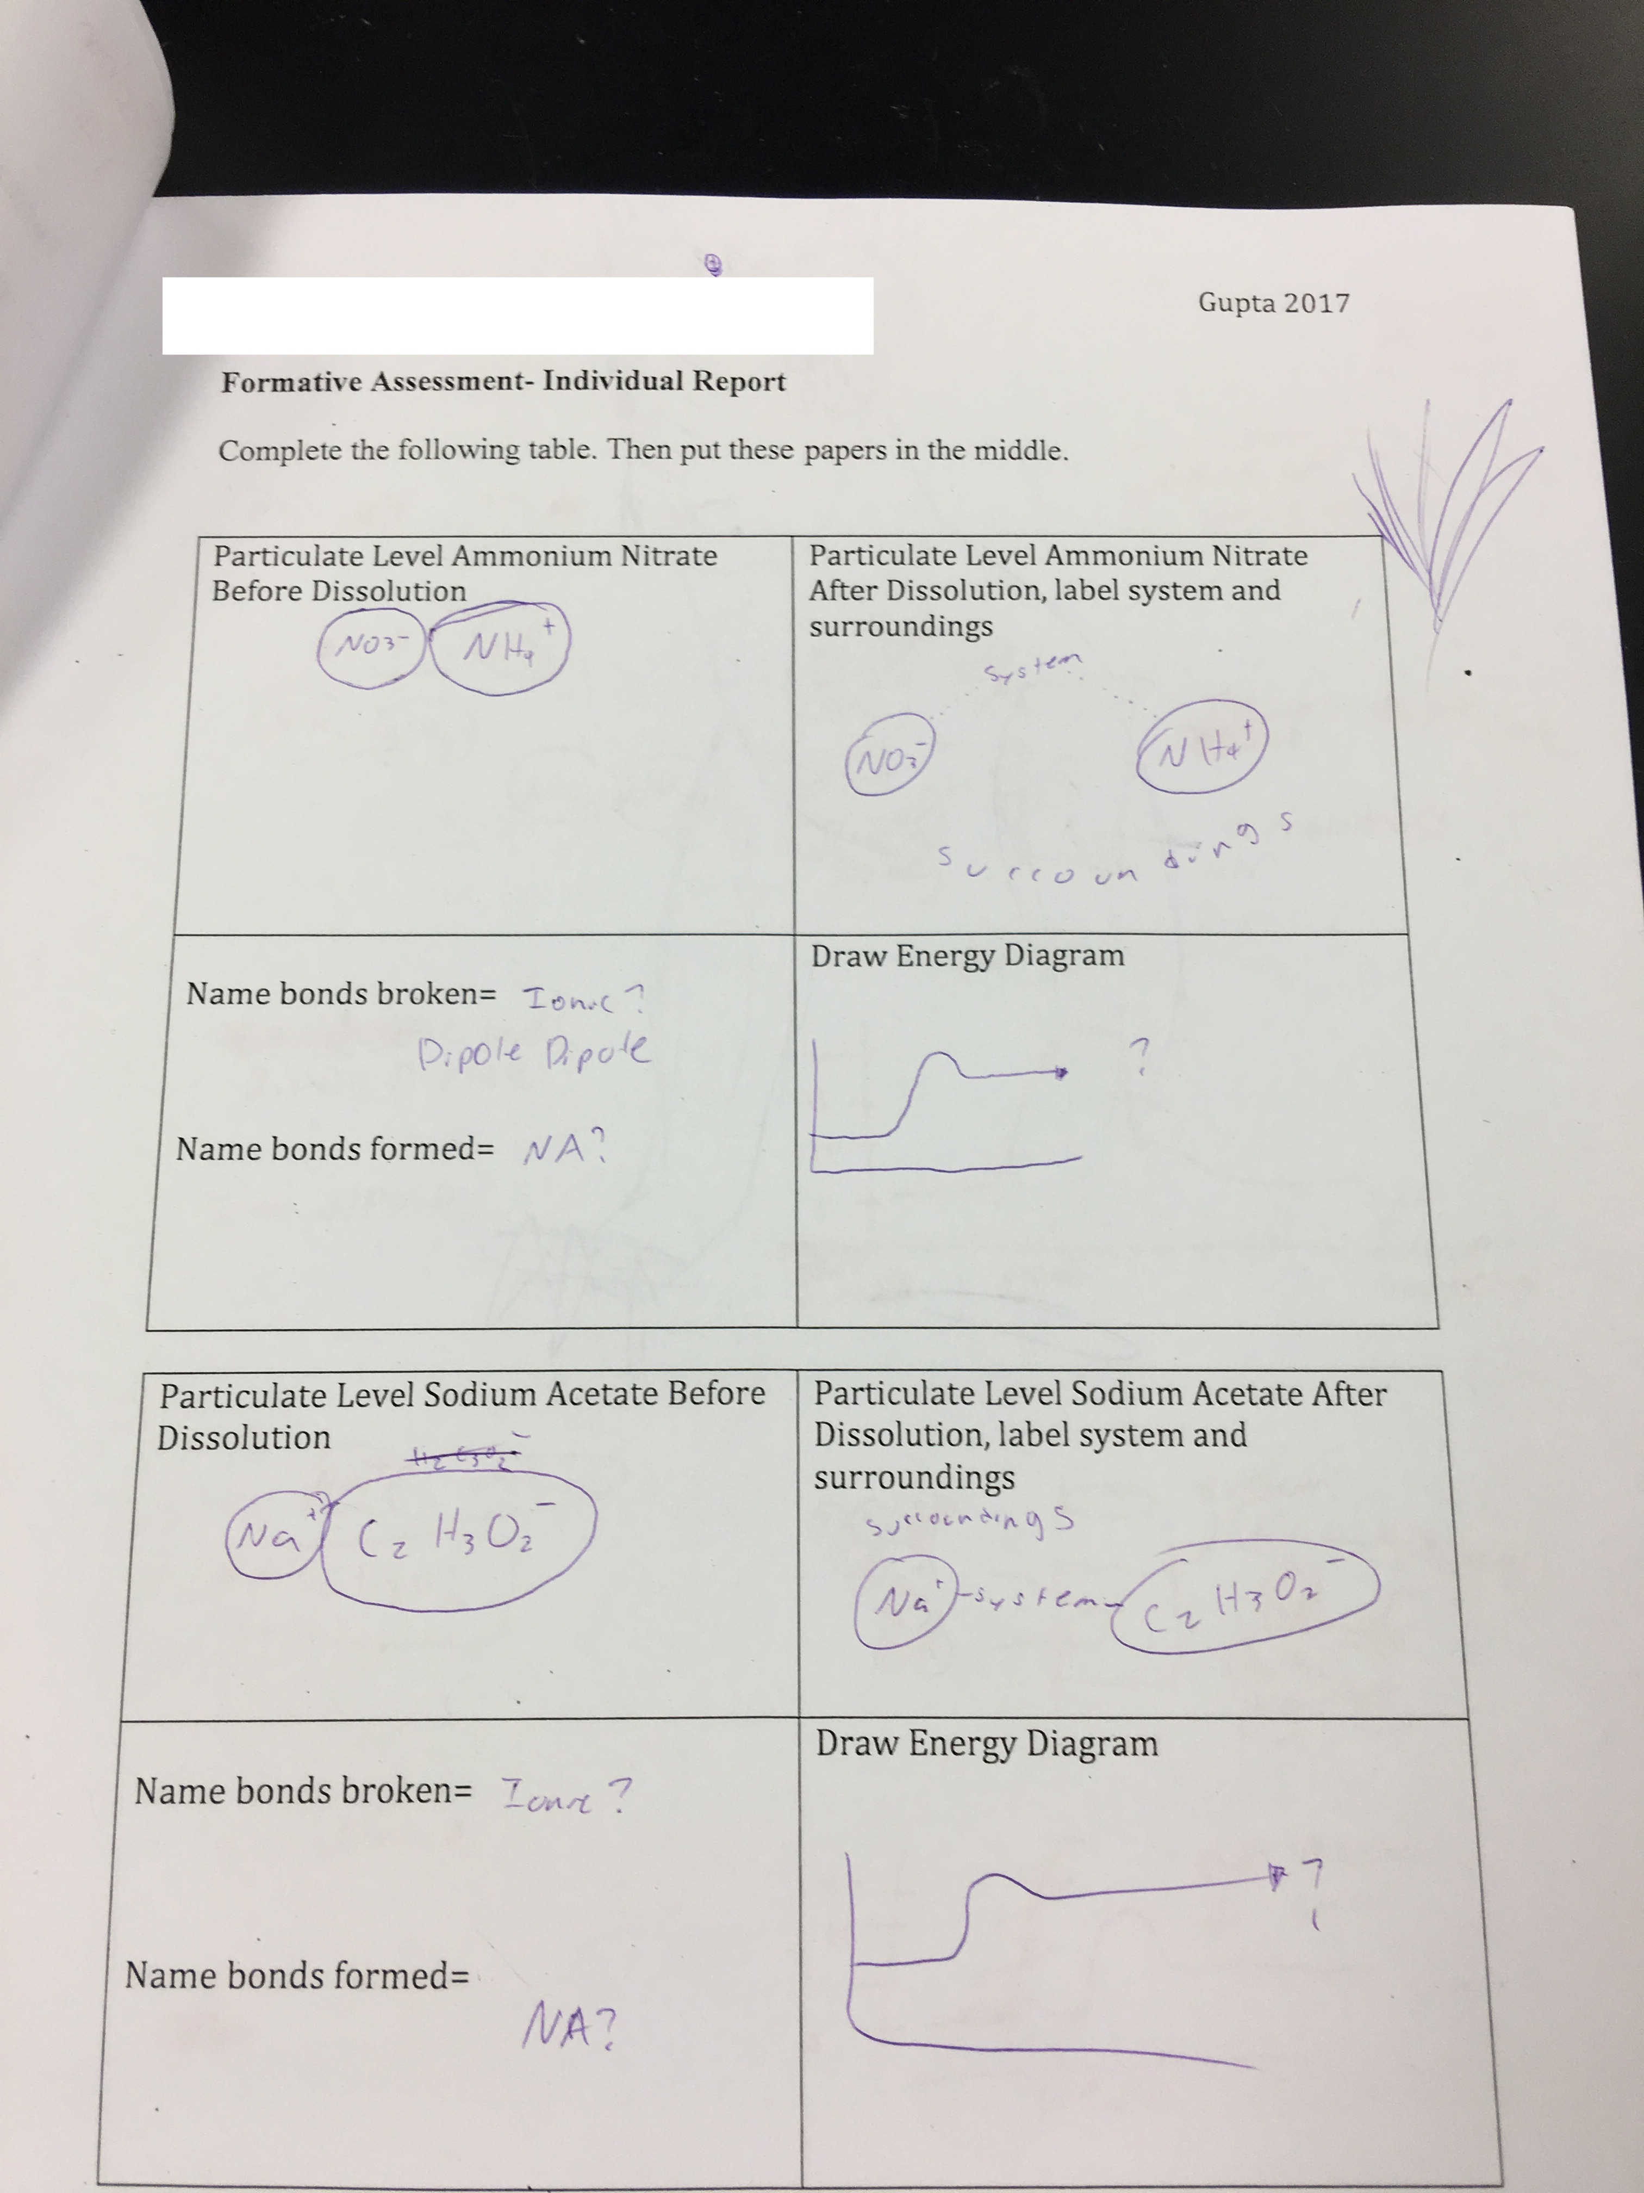

Picture # 6 Day 3 Group Report Picture #7 Day 4 Reflection Form
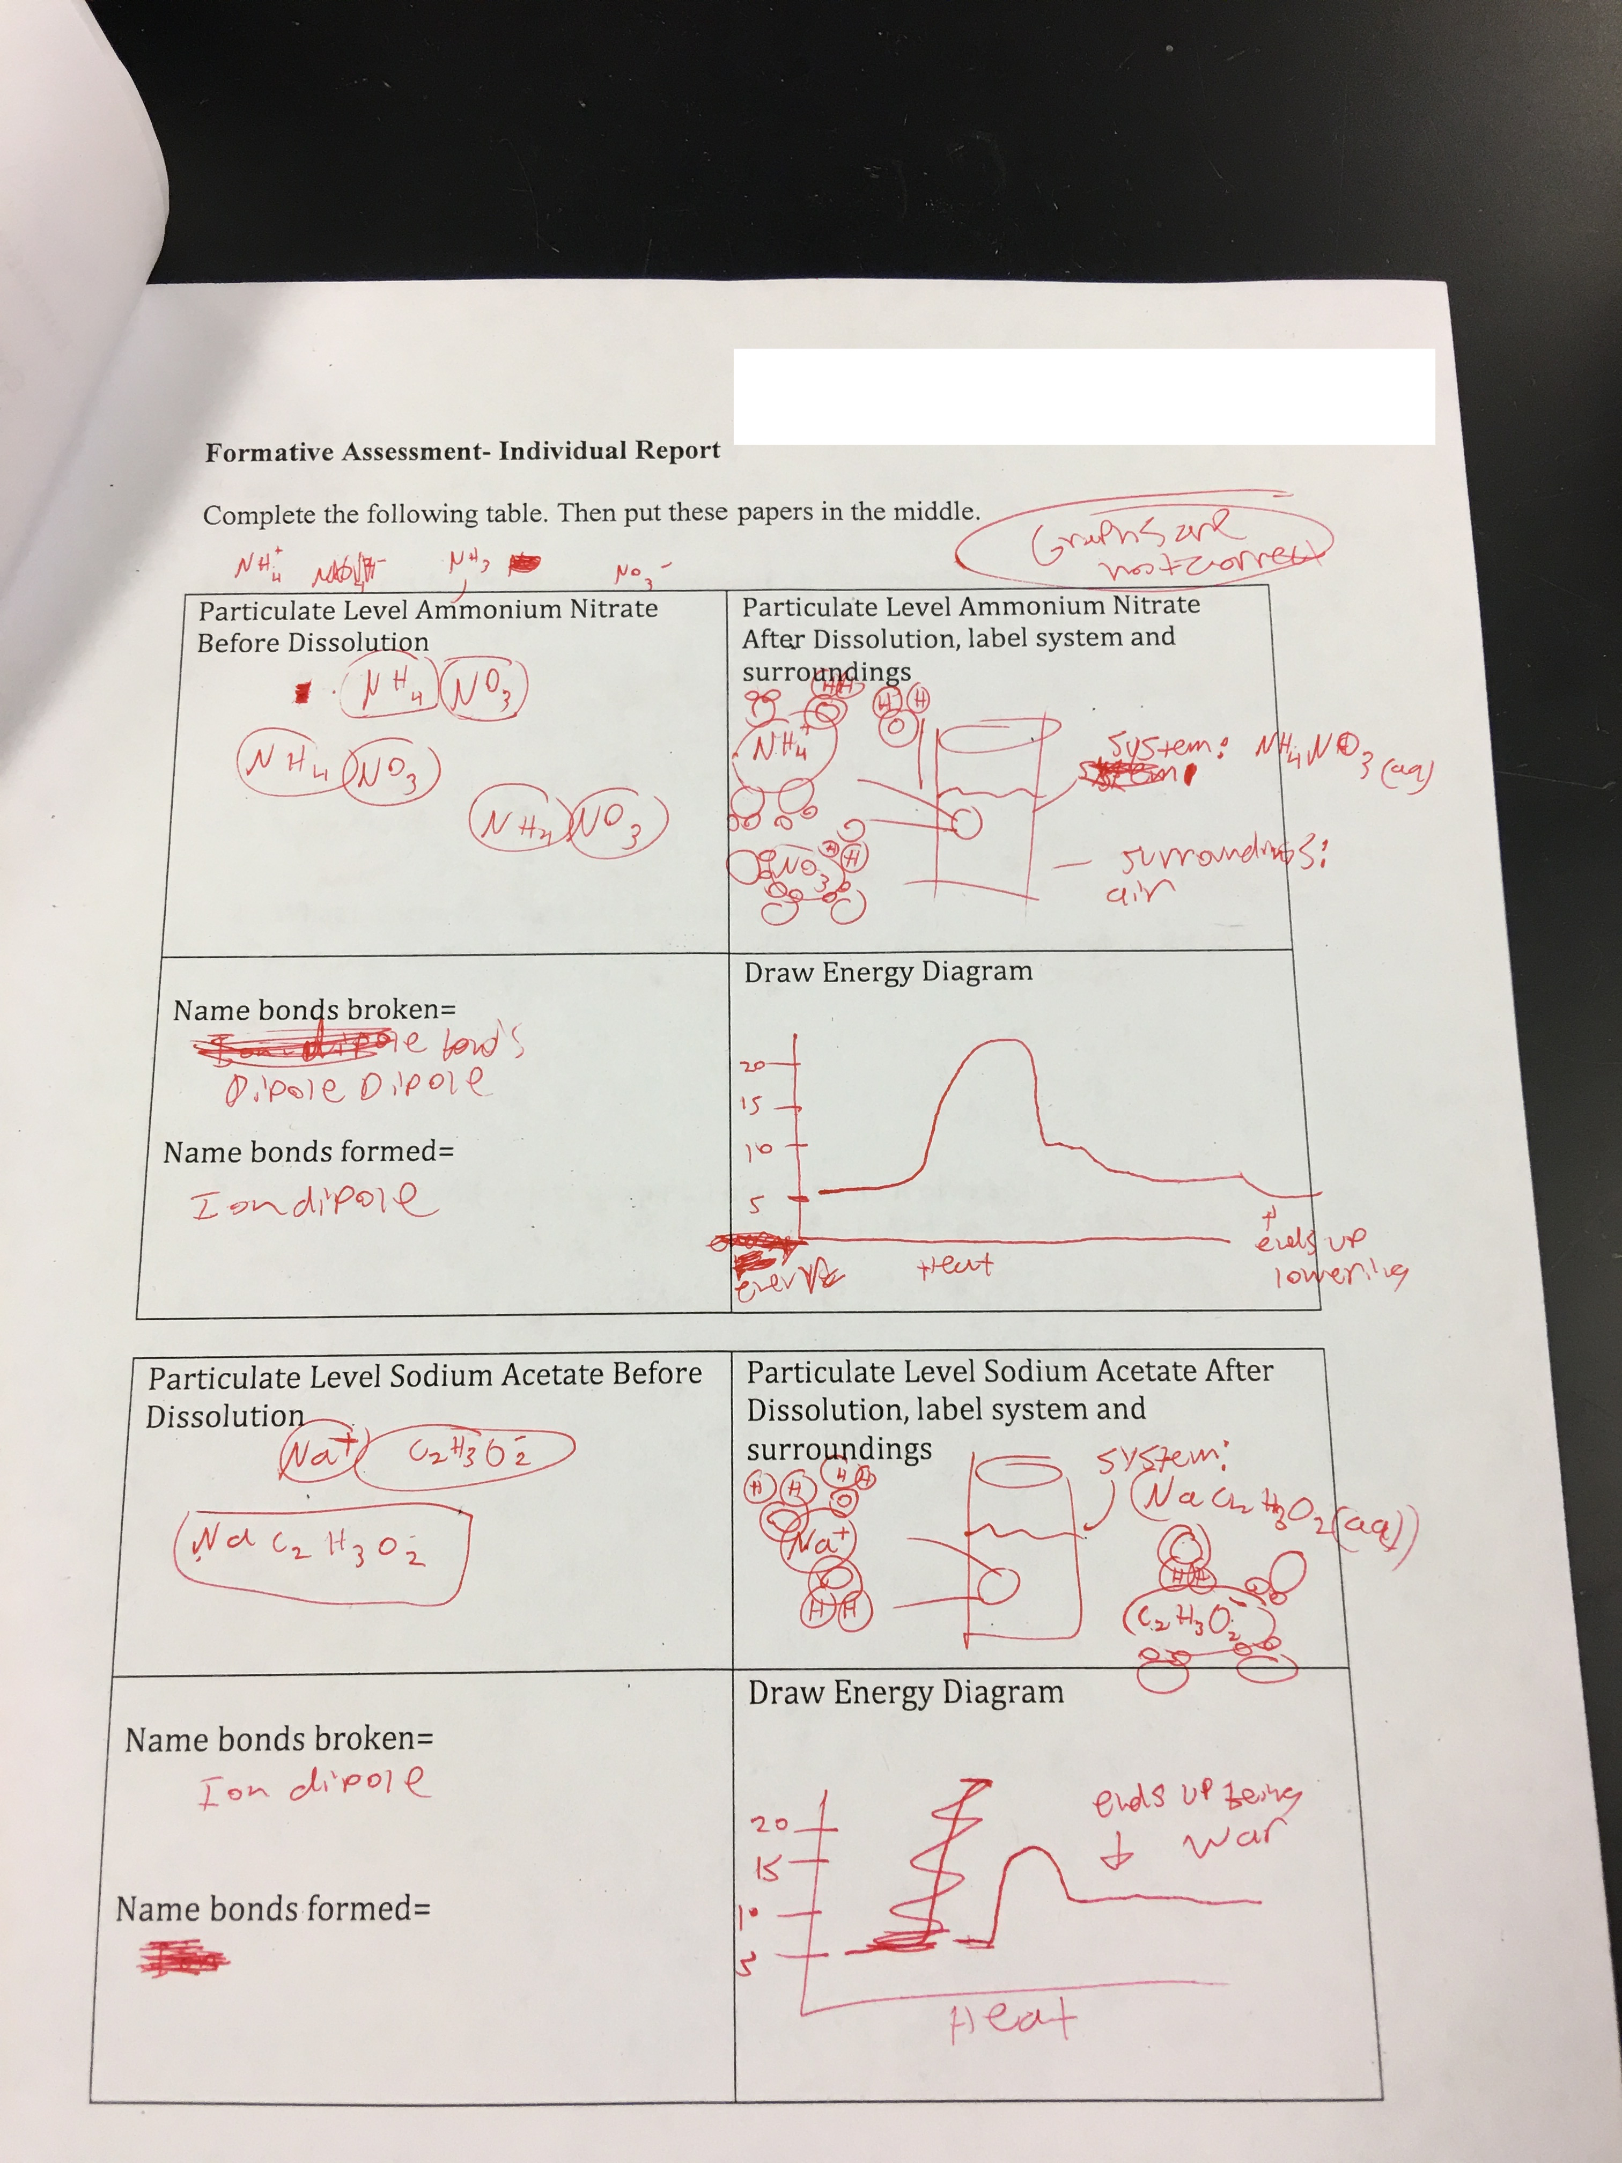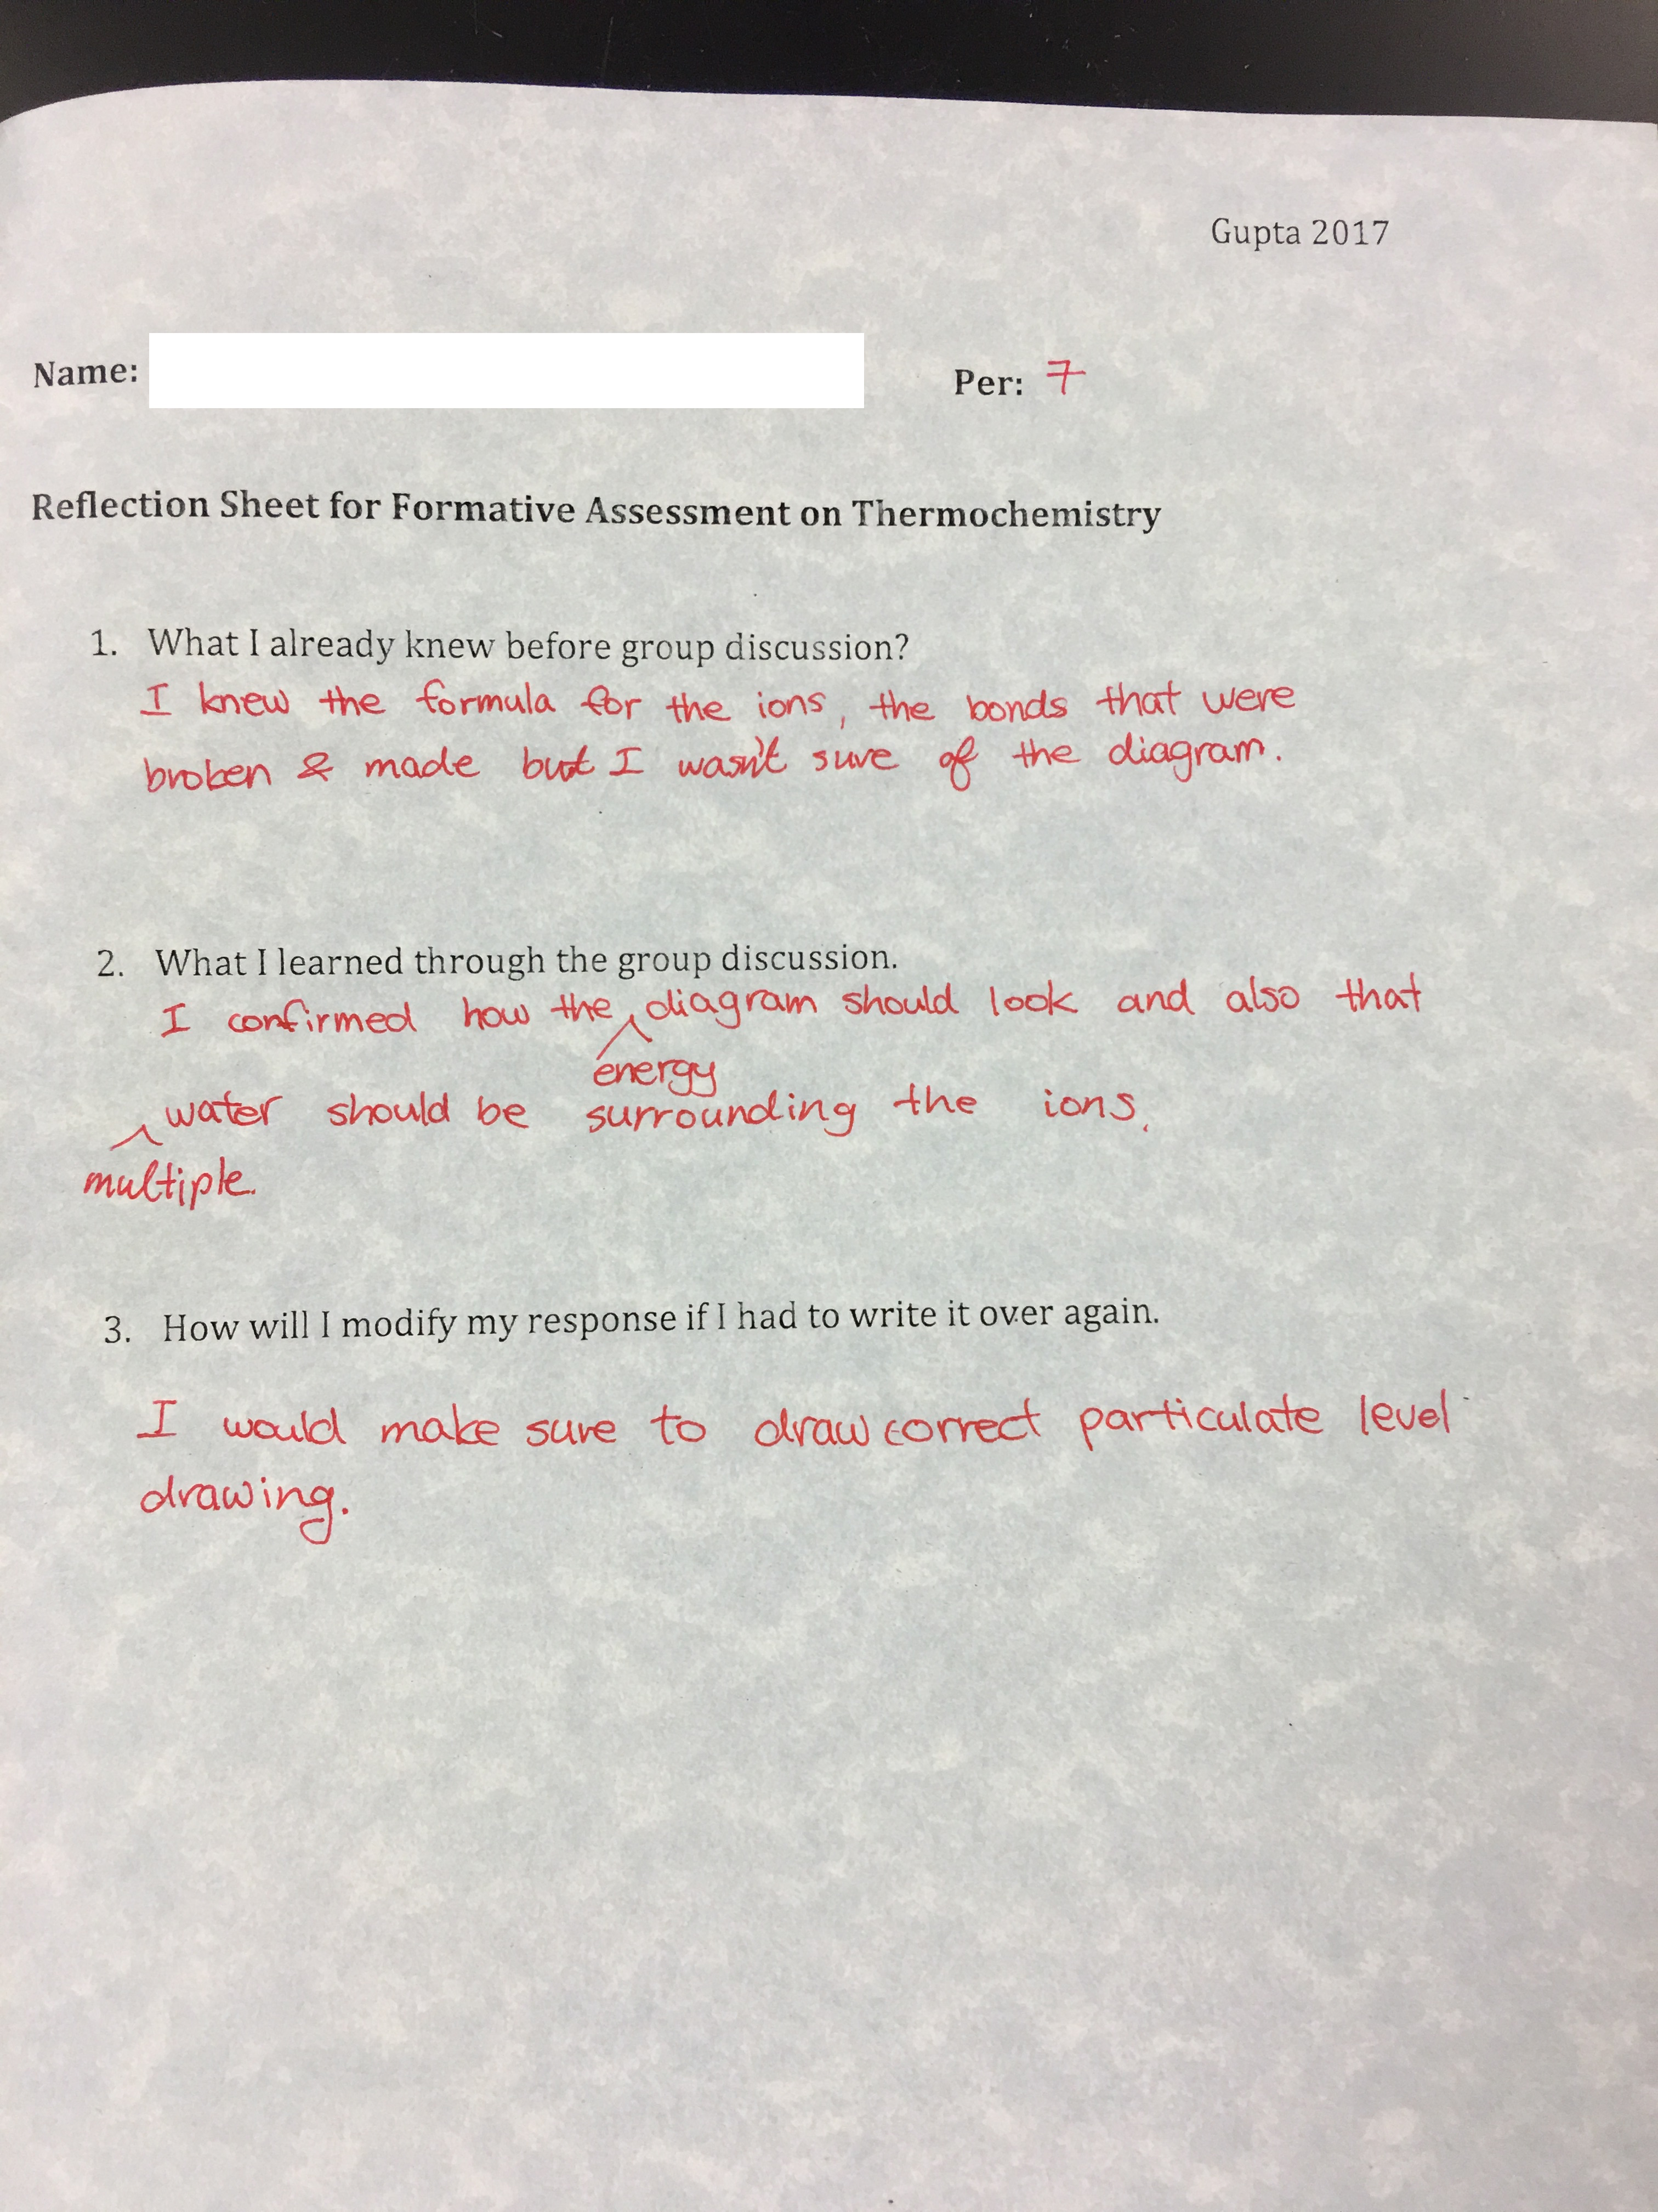

Picture #8 Day 4 Experimental Design Picture #9 Day 5 Research Picture #10 Day 5 Research

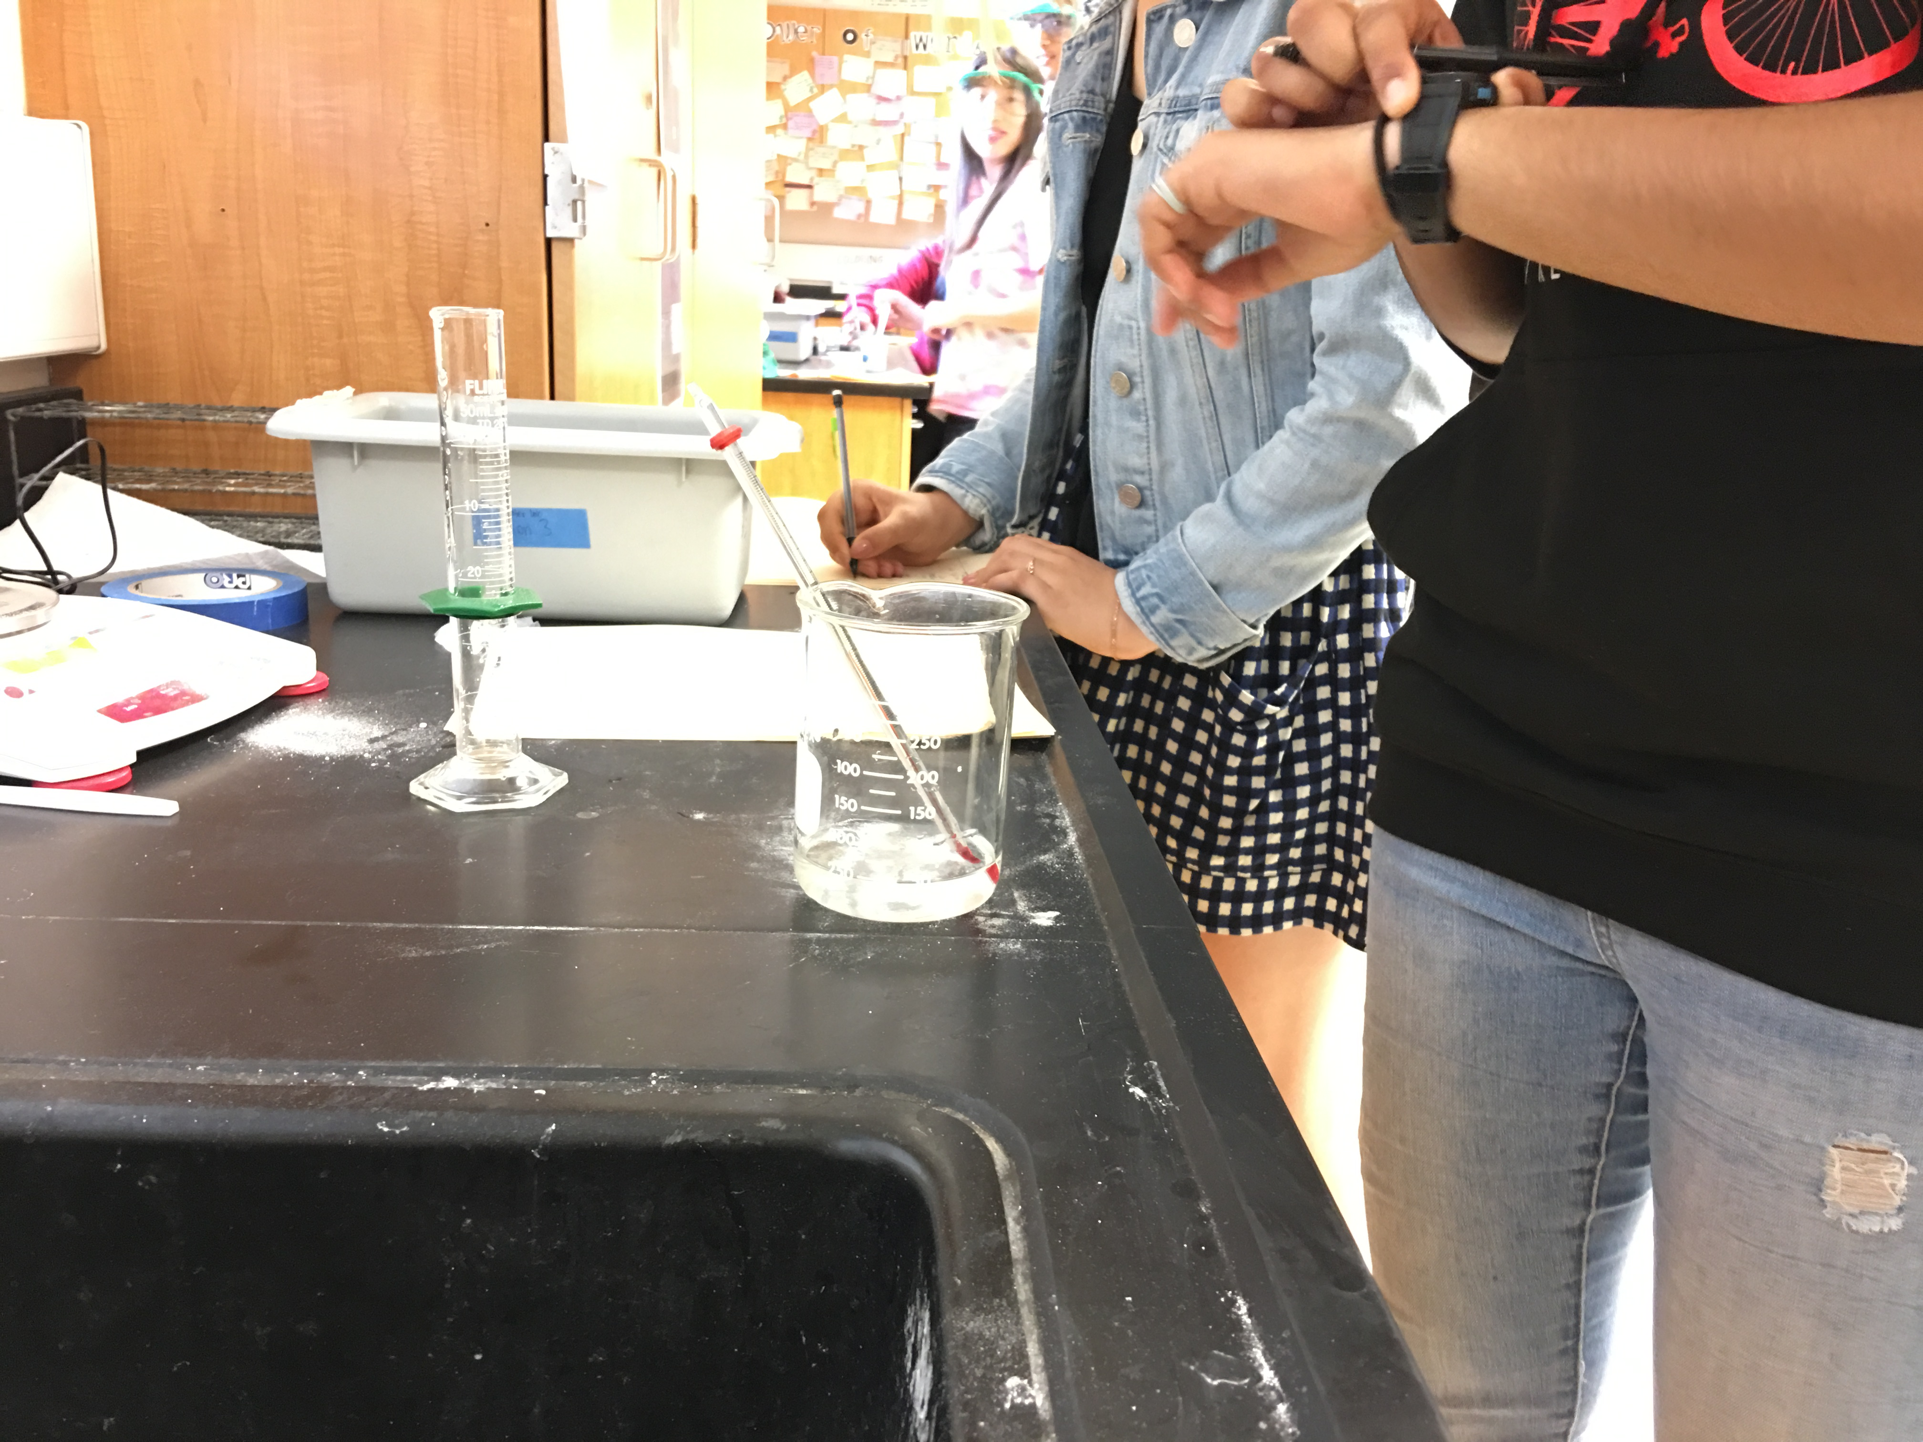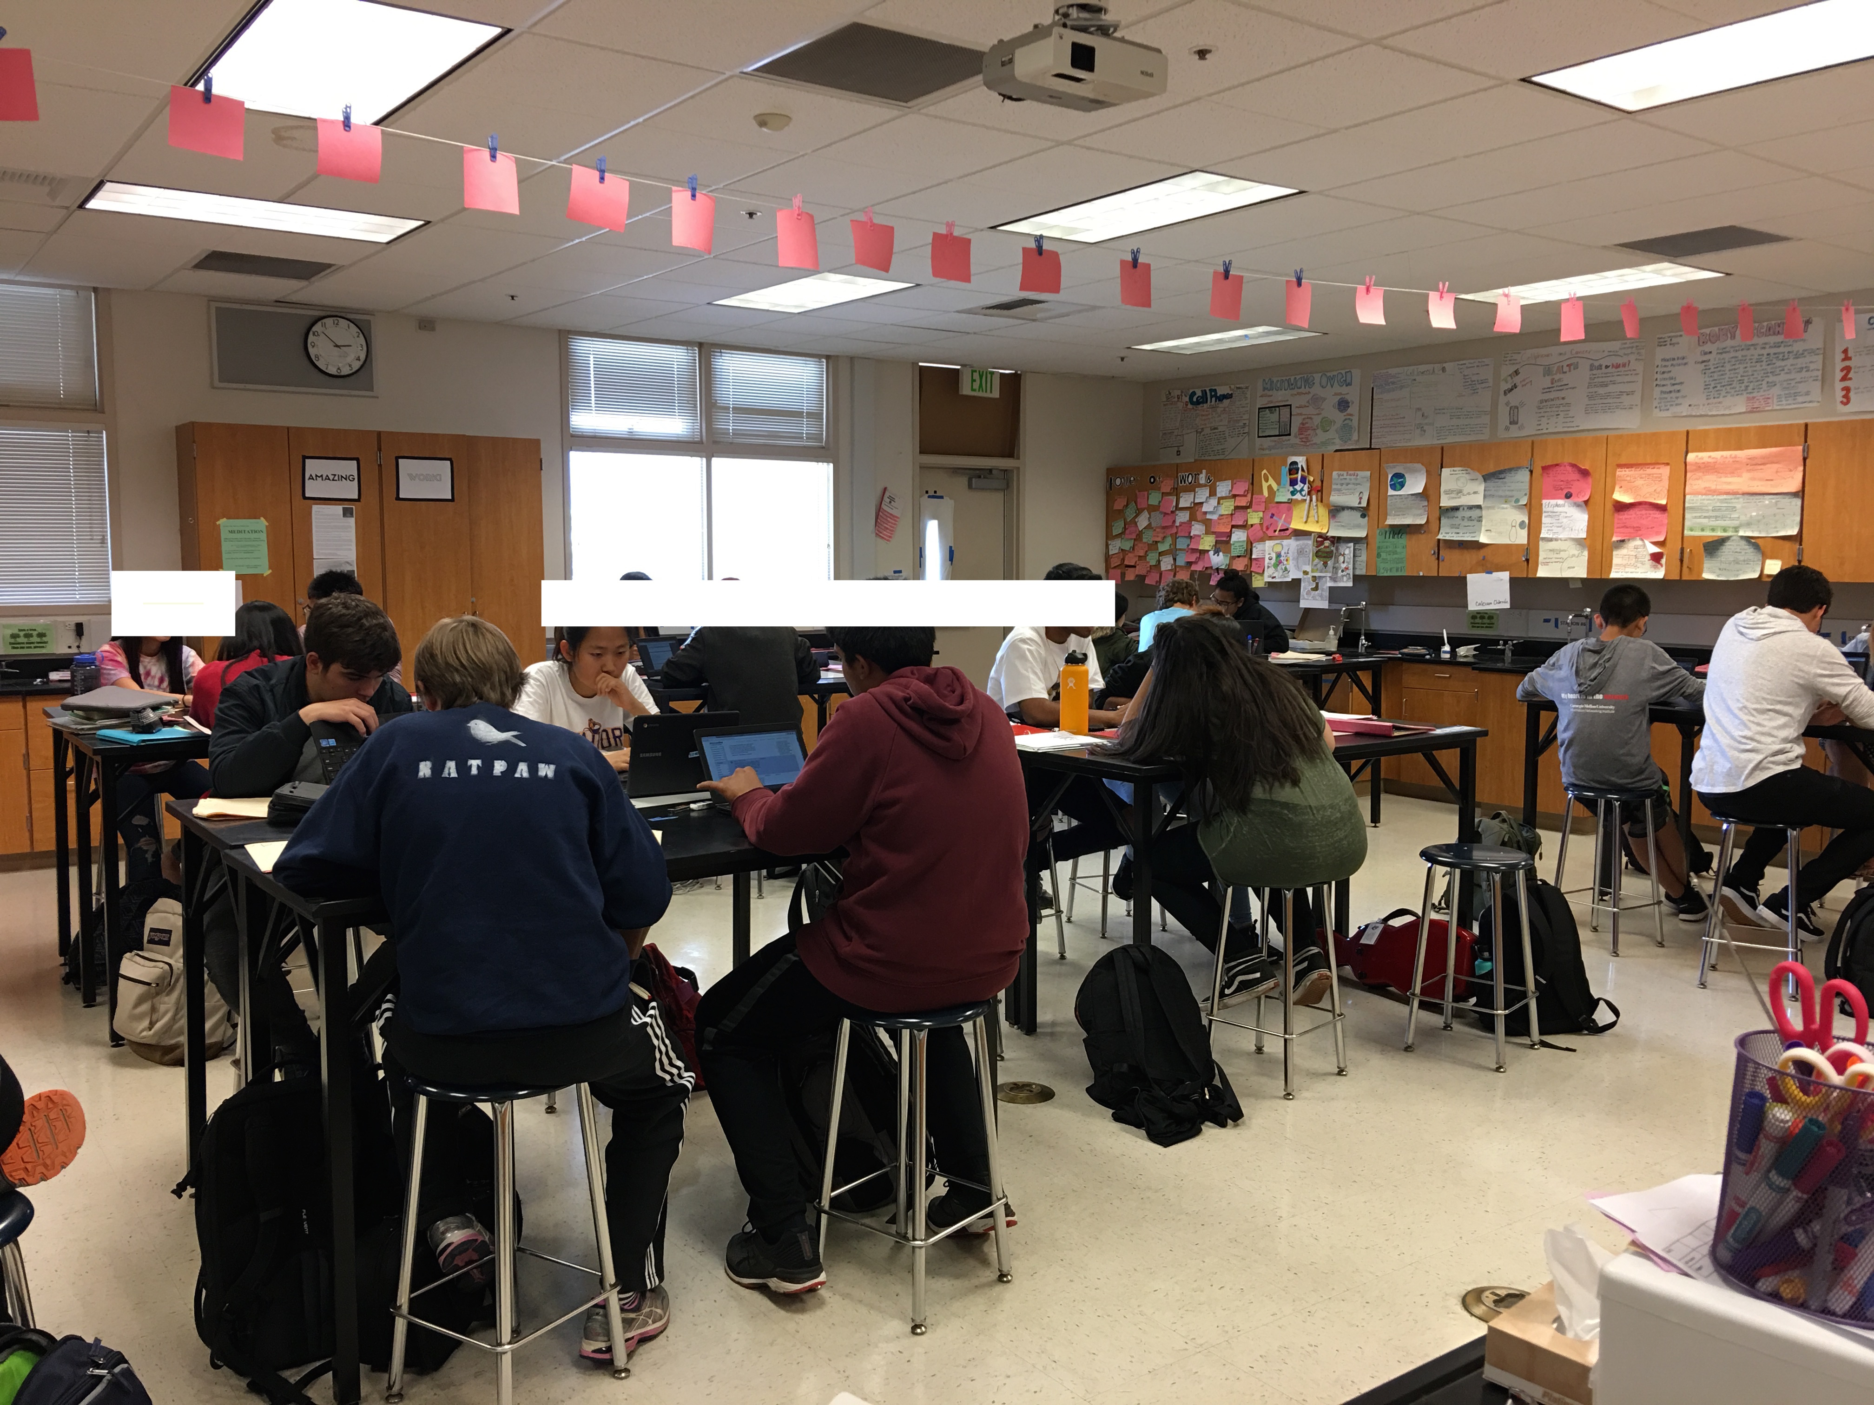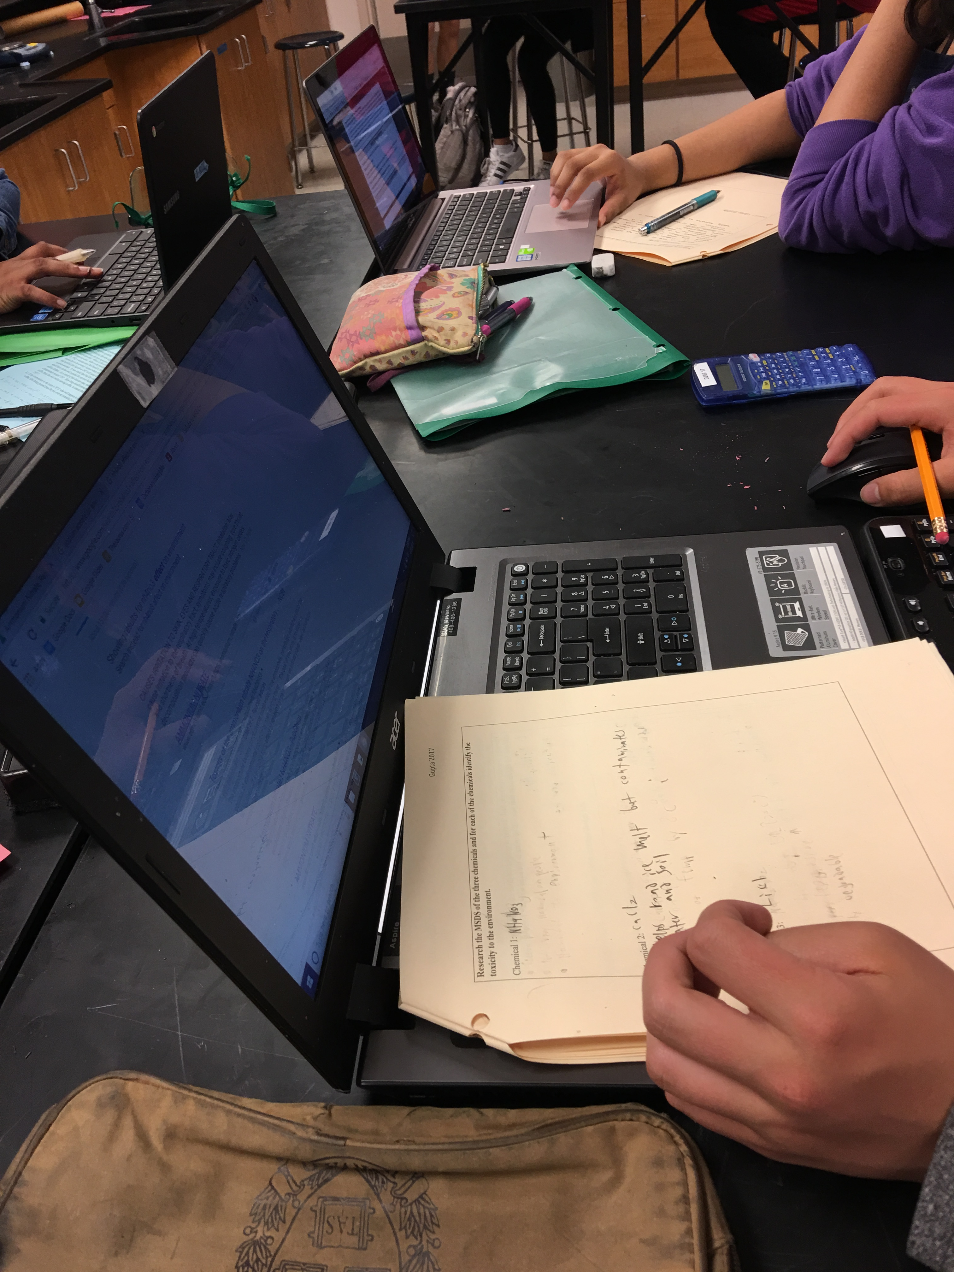

Picture 11 Day 6 Class Data Picture 12 Day 6 Class Data Picture 13 Day 6 Class Data

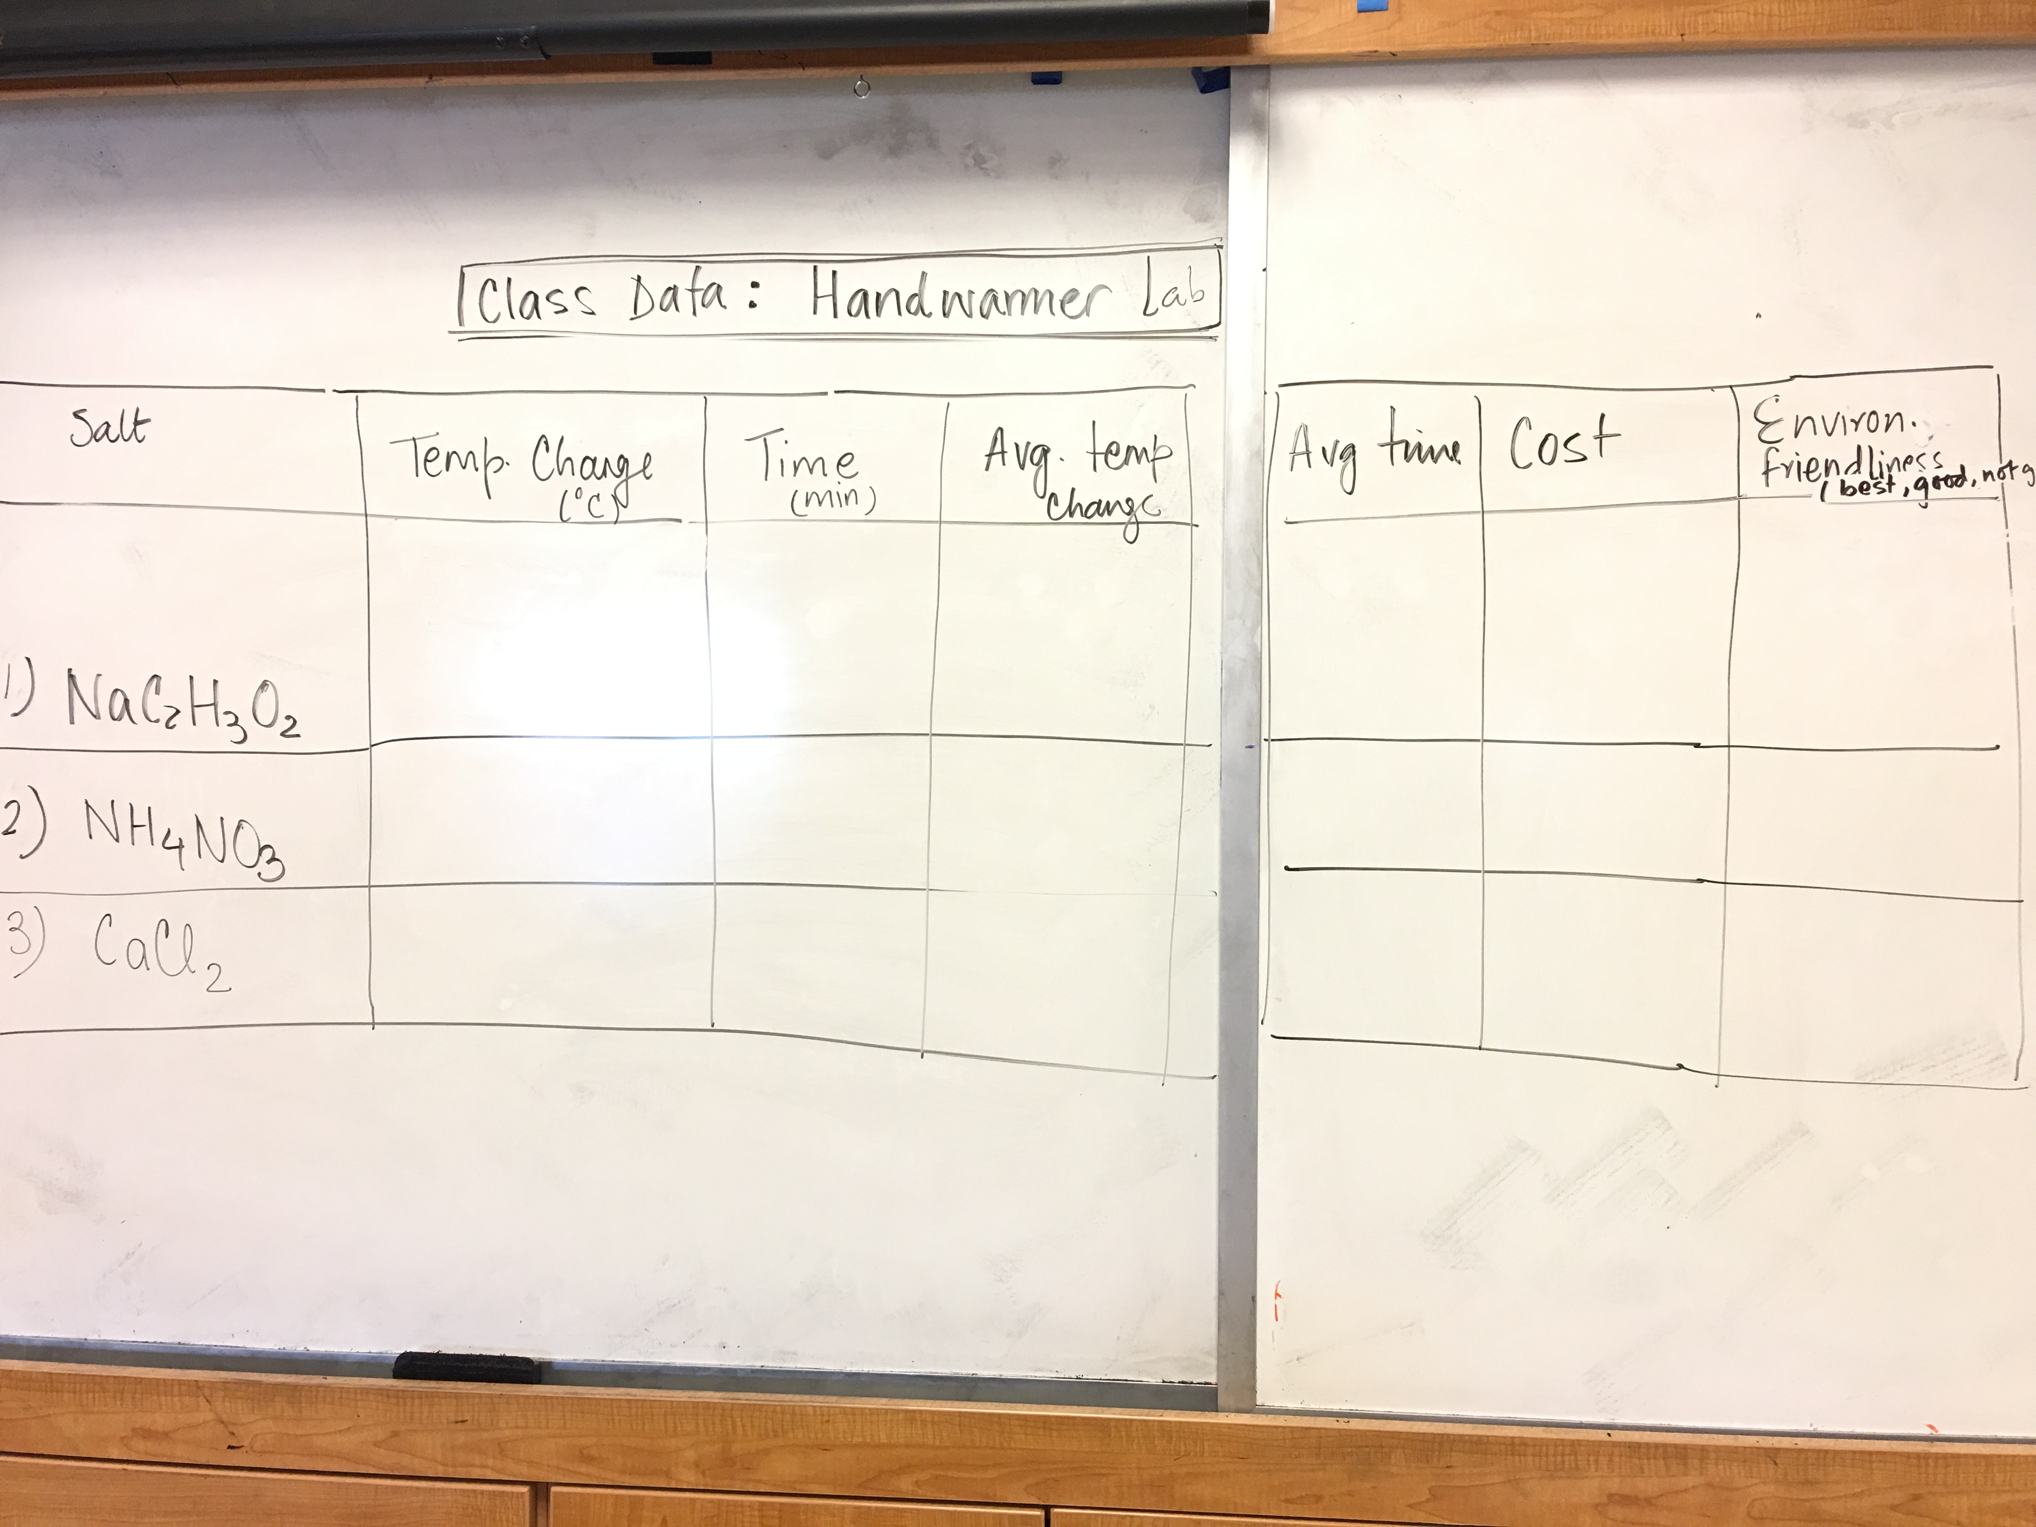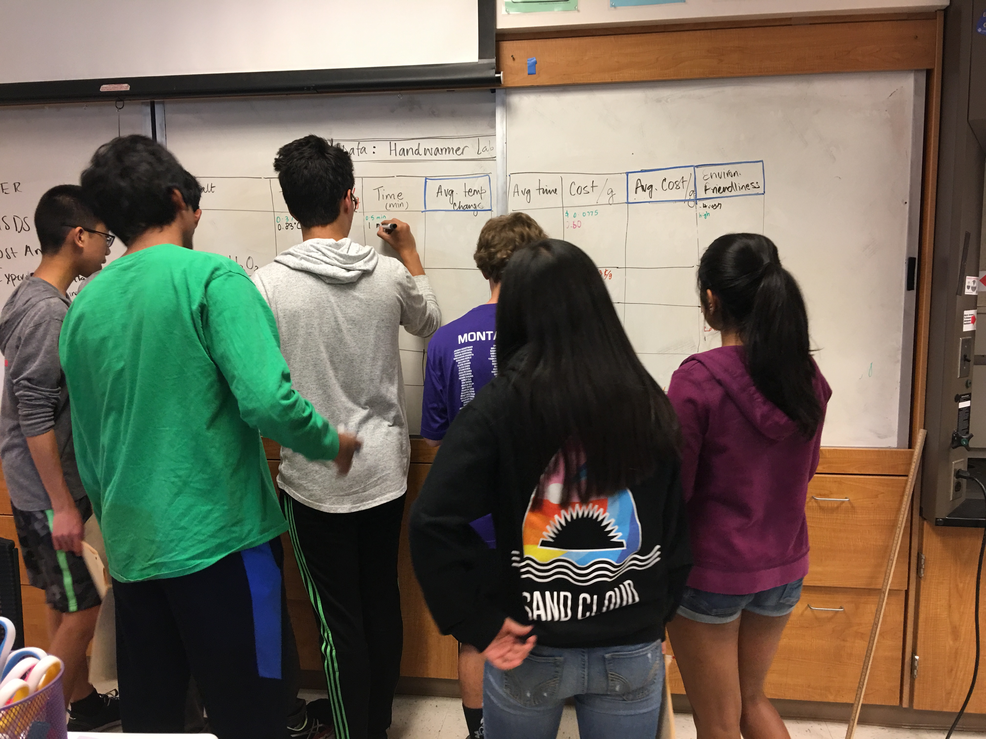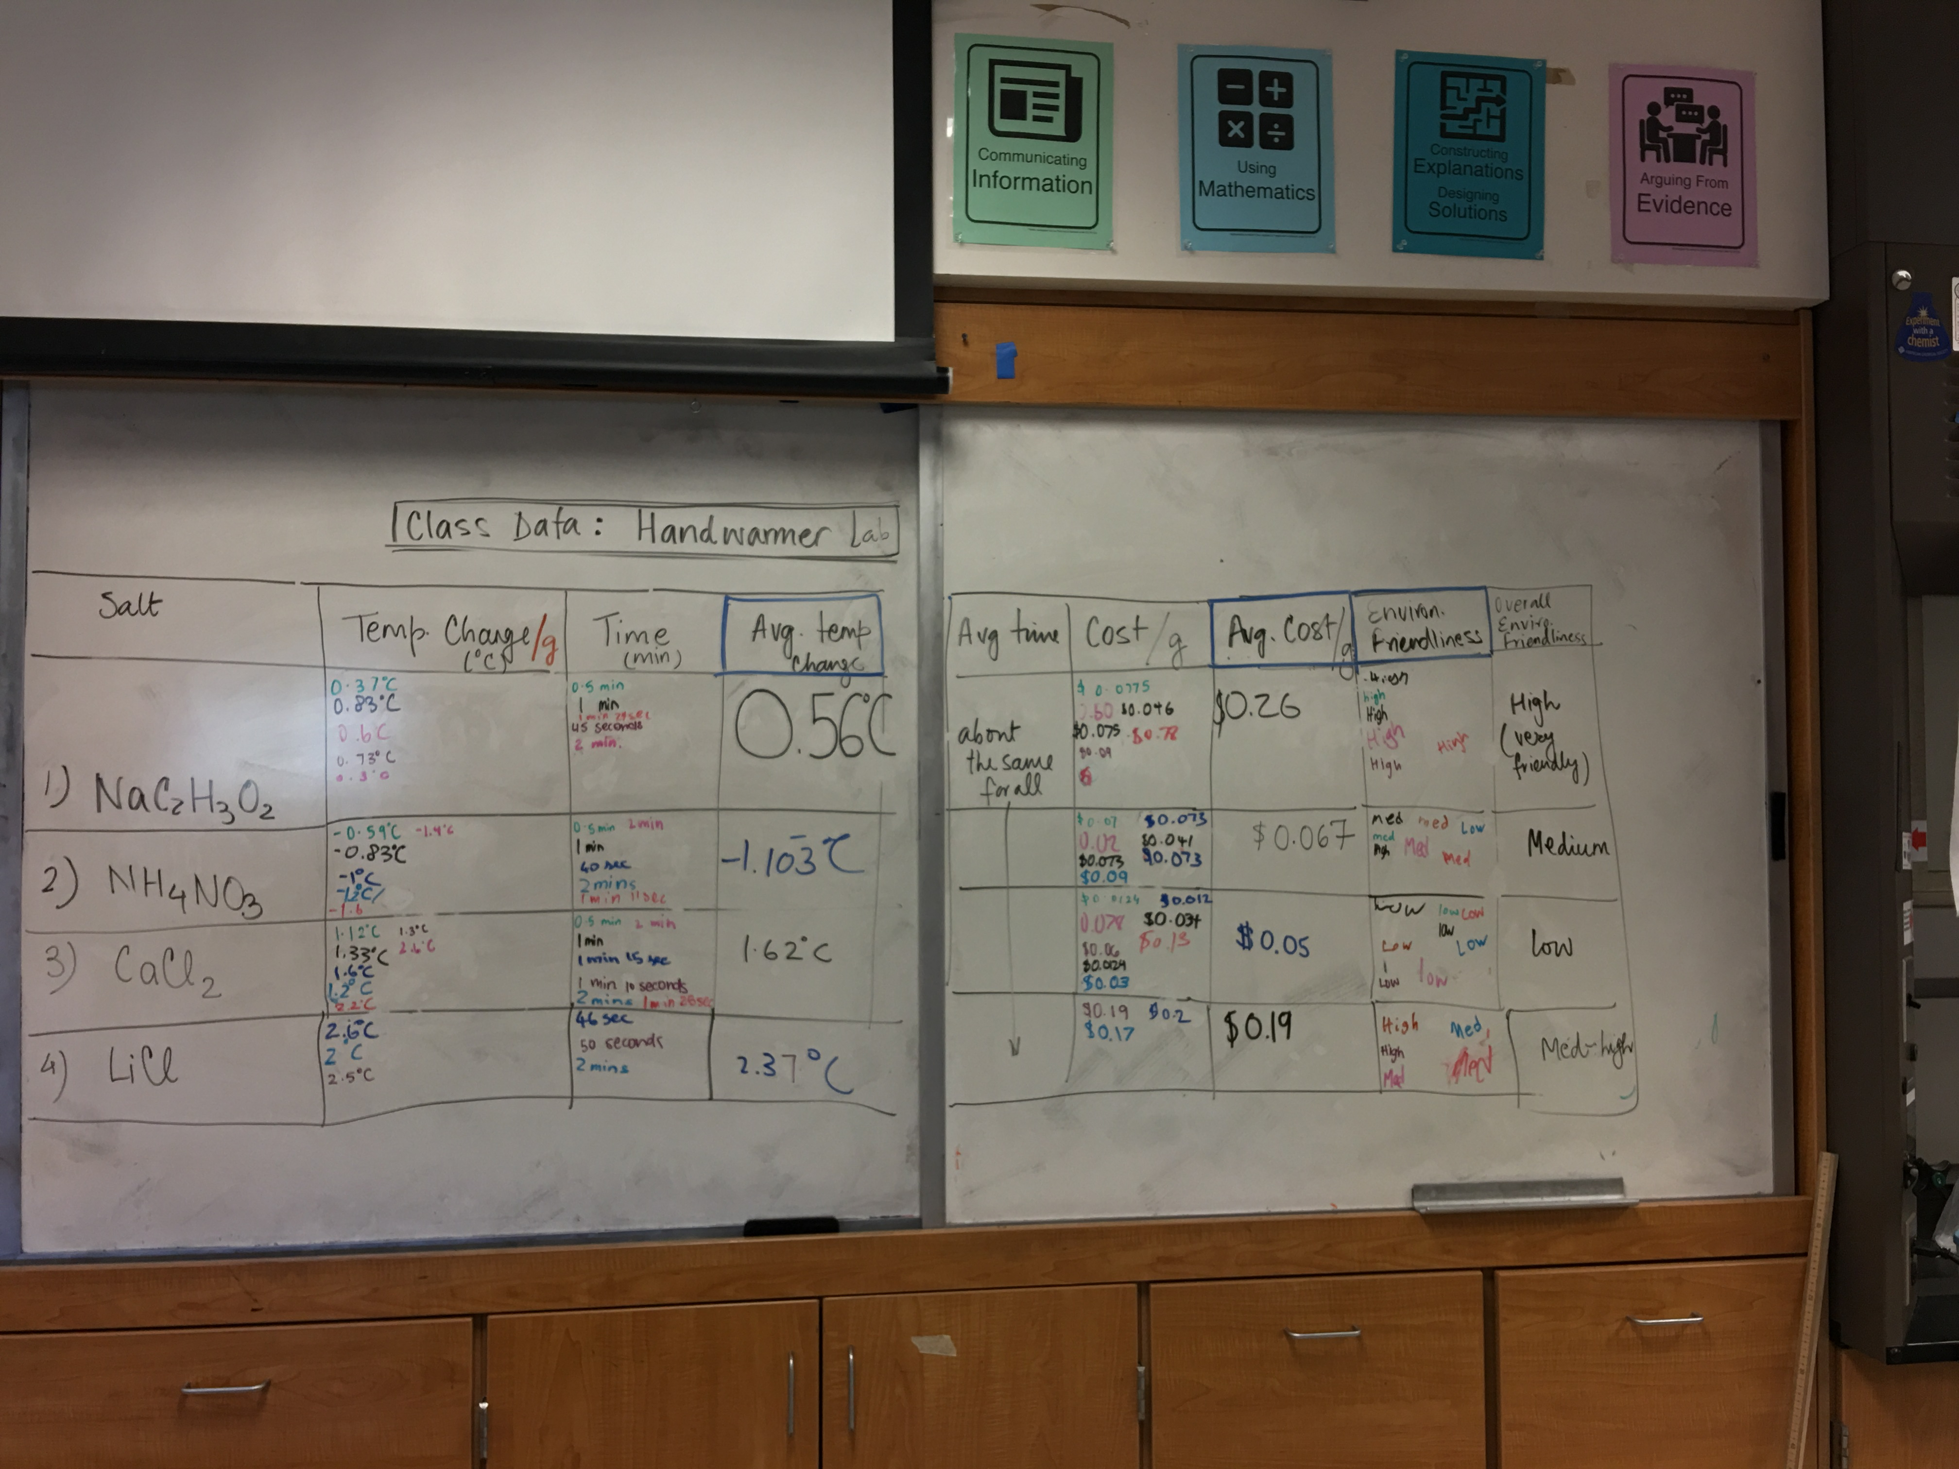

Picture 14, 15, 16 Day 7, Claim, Evidence and Reasoning and Peer Editing

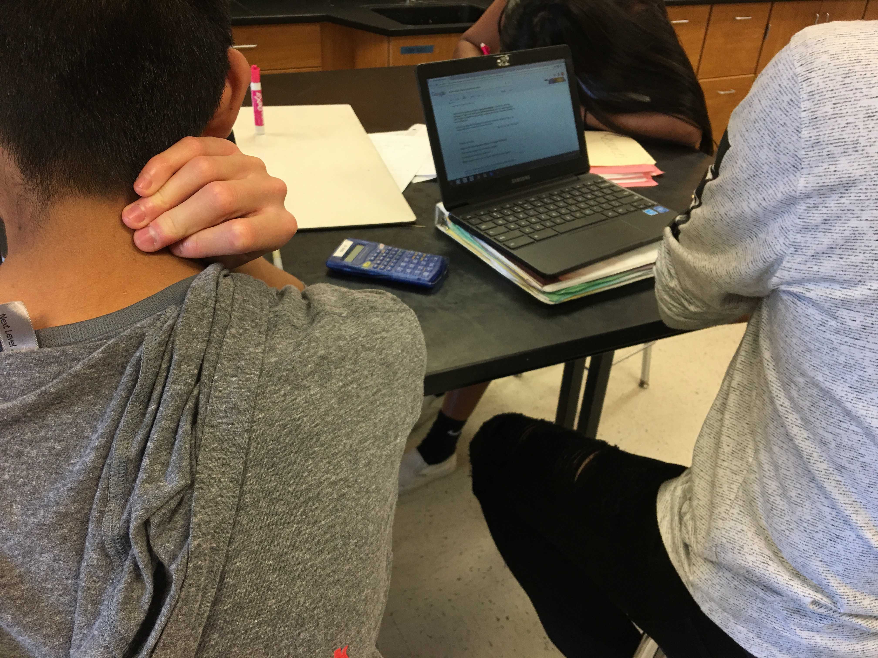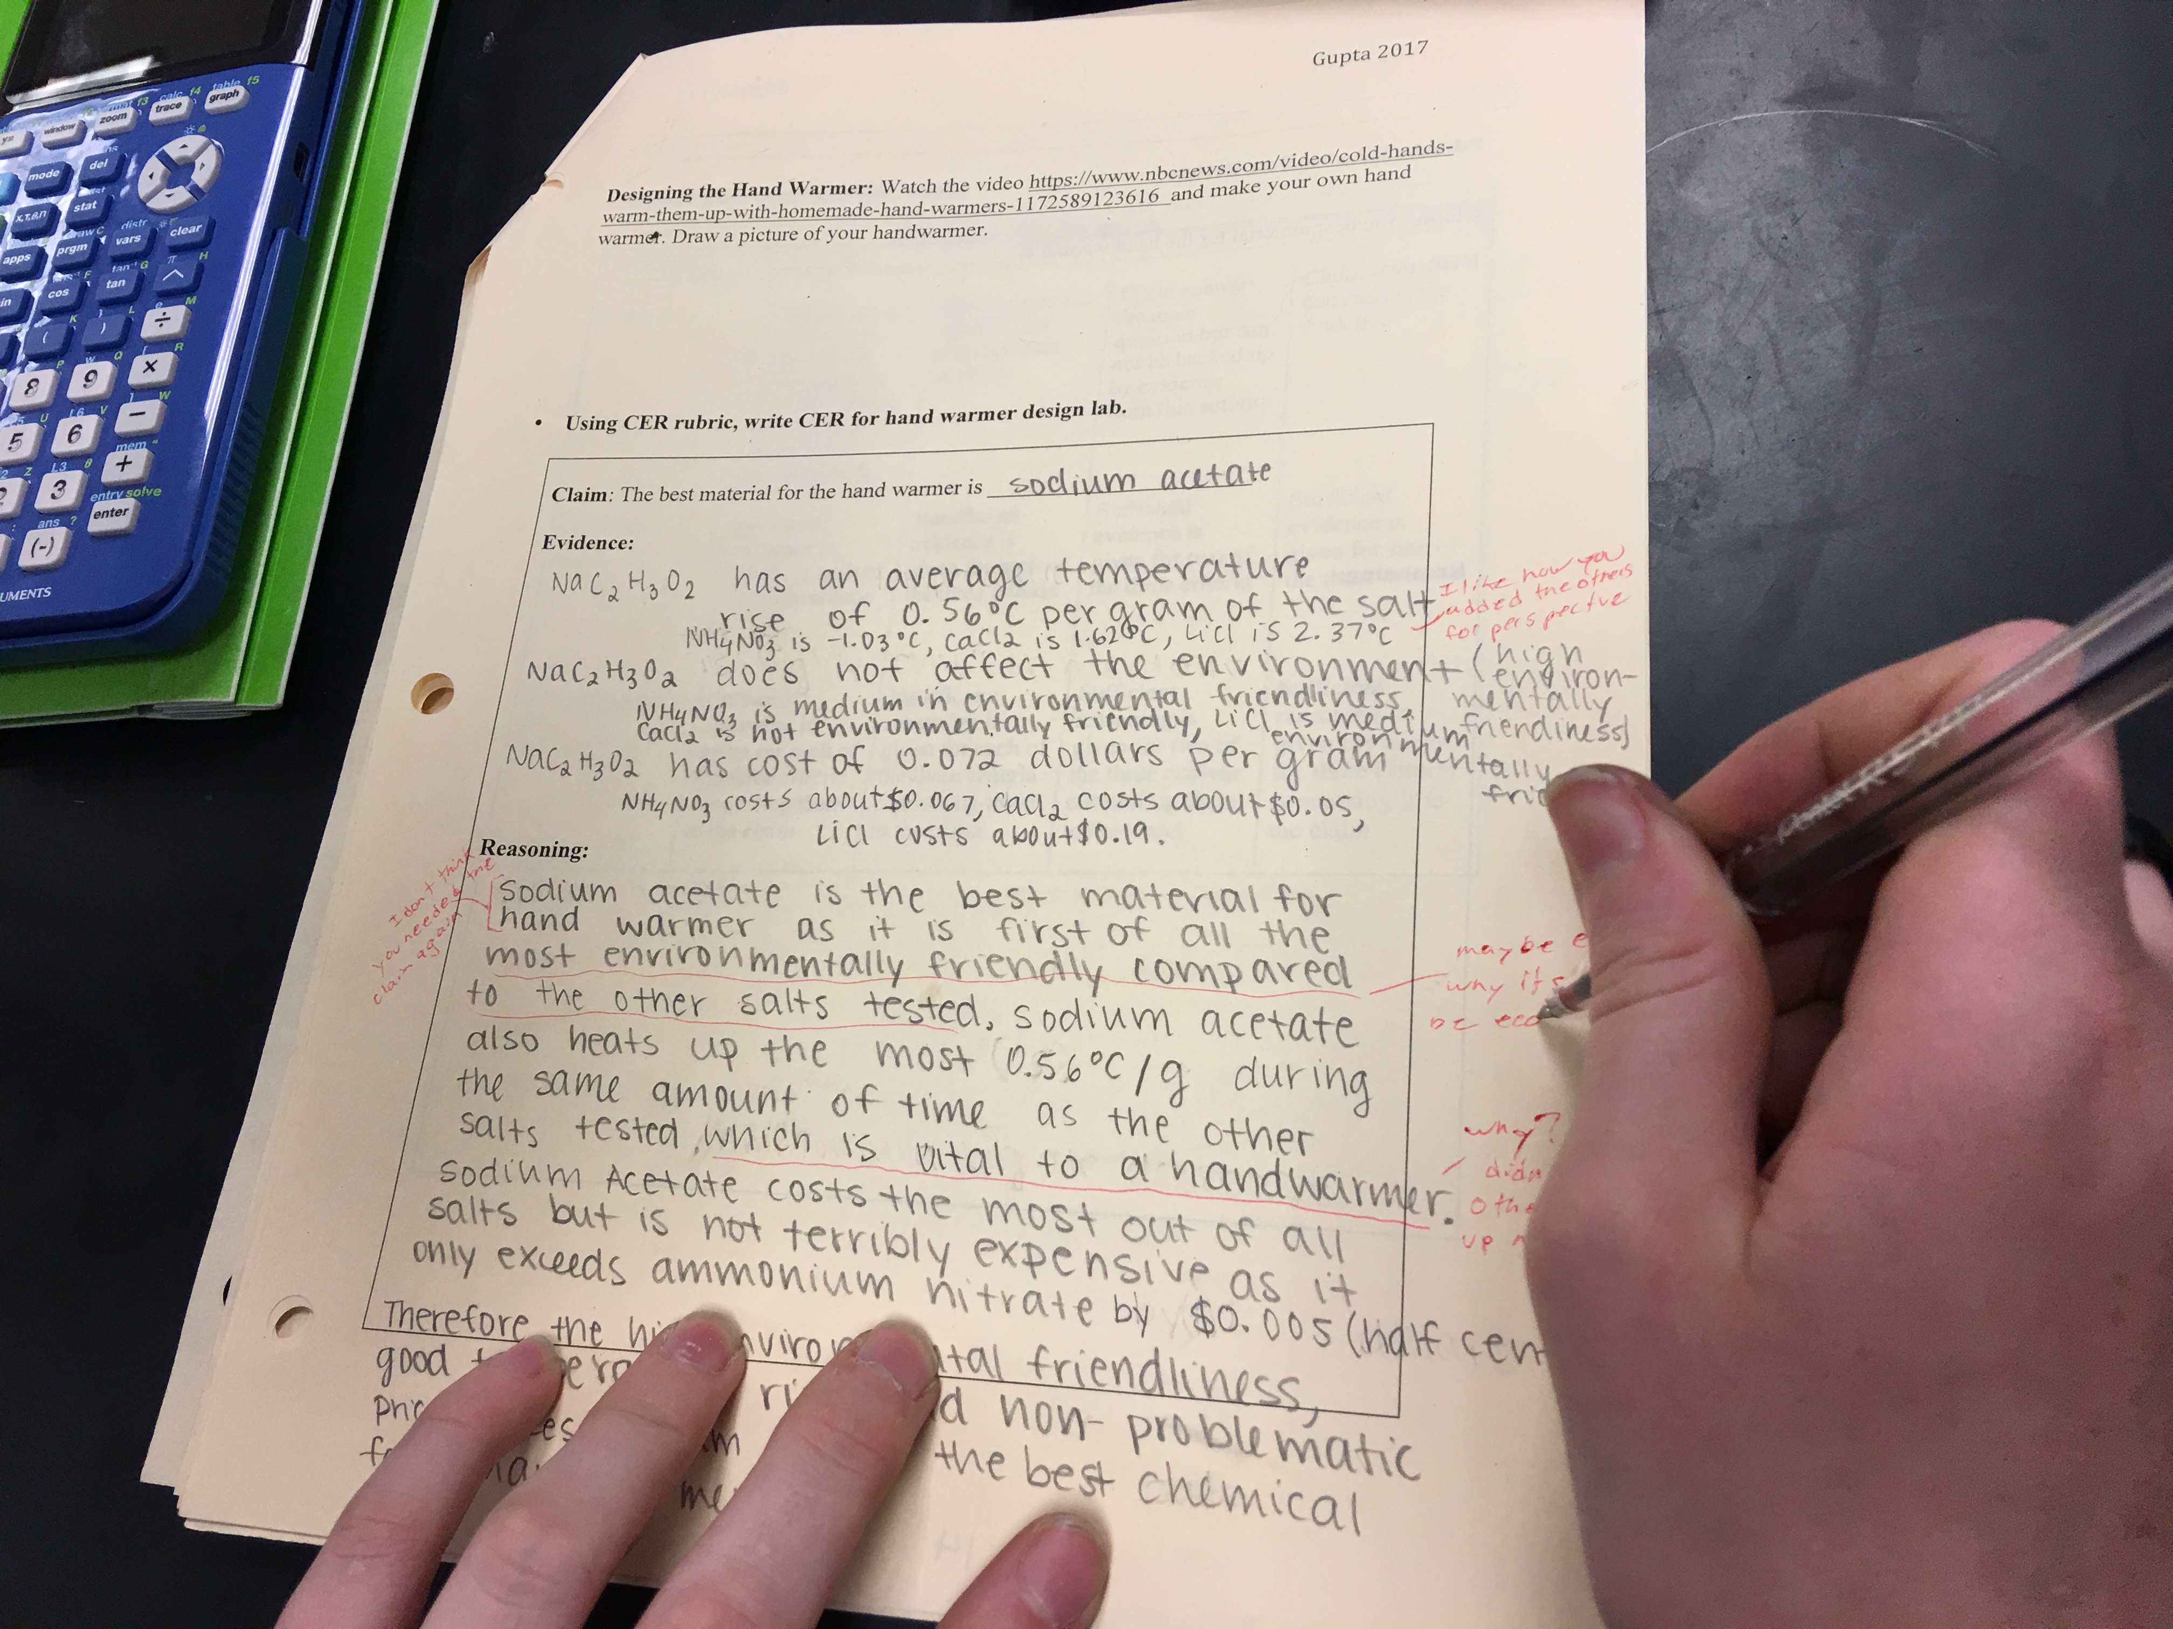

Picture 17 Day 8 Presentations and Debate
